ACTIVE ANTENNA

Antennas that are much shorter than 1/4 wavelength present a very small and highly relative impedance that is dependent on the received frequency. It is difficult to match impedances over a decade of frequency coverage. Instead, input
stage Q1 is an FET source-follower. A high-impedance input successfully bridges antenna characteristics at any frequency.

Transistor Q2 is used as an emitter-follower to provide a high-impedance load for Q1, but more importantly, it provides a low-drive impedance for common-emitter amplifier Q3, which provides all of the amplifier's voltage gain. Transistor
Q4 transforms Q3's moderate output impedance into low impedance, thereby providing sufficient drive for a receiver's 50 ohms, antenna-input impedance. 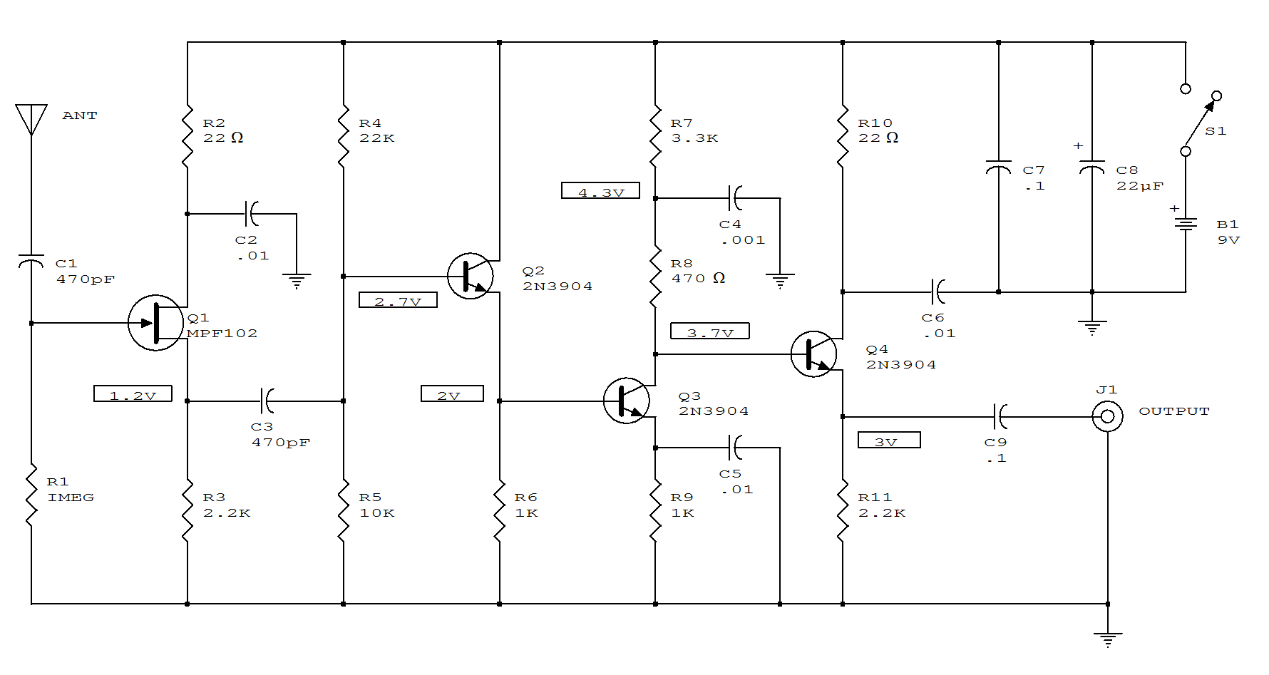
ACTIVE ANTENNA WITH GAIN

The signal booster, built around a few transistors and support components, offers an RF gain of about 12 to 18dB (from about 100kHz to over 30 MHz).
The RF signal is direct-coupled from Q1's source terminal to the base of Q2, which is configured as a voltage amplifier. The output of Q2 is then direct-coupled to the base of Q3 (configured as an emitter- follower amplifier). Transistor Q3 is used to match and isolate the gain stage from receiver's RF-input circuitry.
Inductor L1 is used to keep any power source noise from reaching the FET(Q1) and any value of RF choke 0.5 to 2.5 mH will do. The value of R2 sets the Q2 bias at about 2V. If the voltage is less than 2V, increase the value of R2 to 1.5k ohm. To go below 100kHz (to bottom of the RF spectrum), increase the value of C1 to 0.002uF. The antenna is short pull-up type (42" to 86" long).
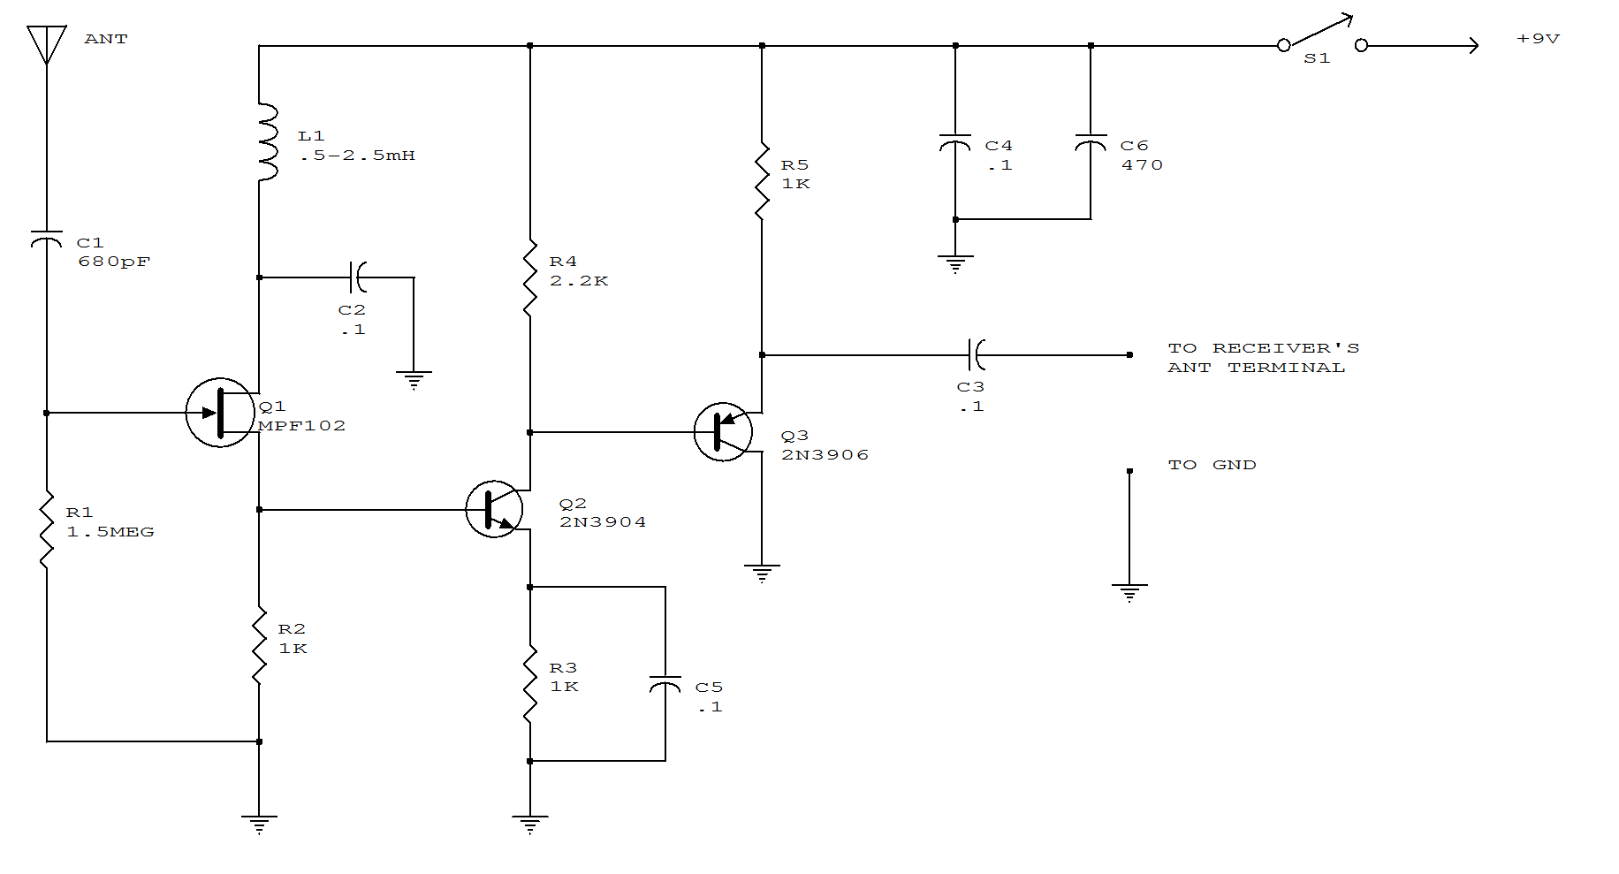

AUTO ALARM

In operation, the alarm circuit allows a 0 - 47 second time delay, as determined by the R1 /C1 combination, after the switch is armed to allow the vehicle's motion sensor to settle down. This allows you time to get a bag of groceries out of the trunk and not have the hassle of juggling the groceries and the key switch at once.
During the time delay, half of LED1, which is actually a single, bi-colored, three-legged common cathode device, lights green. At the same time, pins 8 and 4 of U2 (a 555 oscillator/timer) are held low by Ul (a 3905 oscillator/timer), causing the alarm to remain silent. Once the delay is over, LED1 turns red, indicating that the circuit is armed.
At that point, a ground at pin 2 of U2 forces pin 3 of U2 high, closing the contacts of Kl and sounding the siren for a time duration determined by R4 and C2. Once the time has elapsed, pin 3 is pulled low, Kl opens, and the circuit is again ready to go. The circuit can be manually reset by the simple expedient of opening and closing the key switch. Potentiometer R3 controls the LED's illumination intensity. Diode D1 ensures that the green segment of LED1 is fully extinguished when Ql is turned on-which turns the LED to red. Resistors R4 and R5 must be connected to the + V bus. not to pin 7 of Ul. otherwise U2 will mysteriously trigger itself each time the initial delay ends.
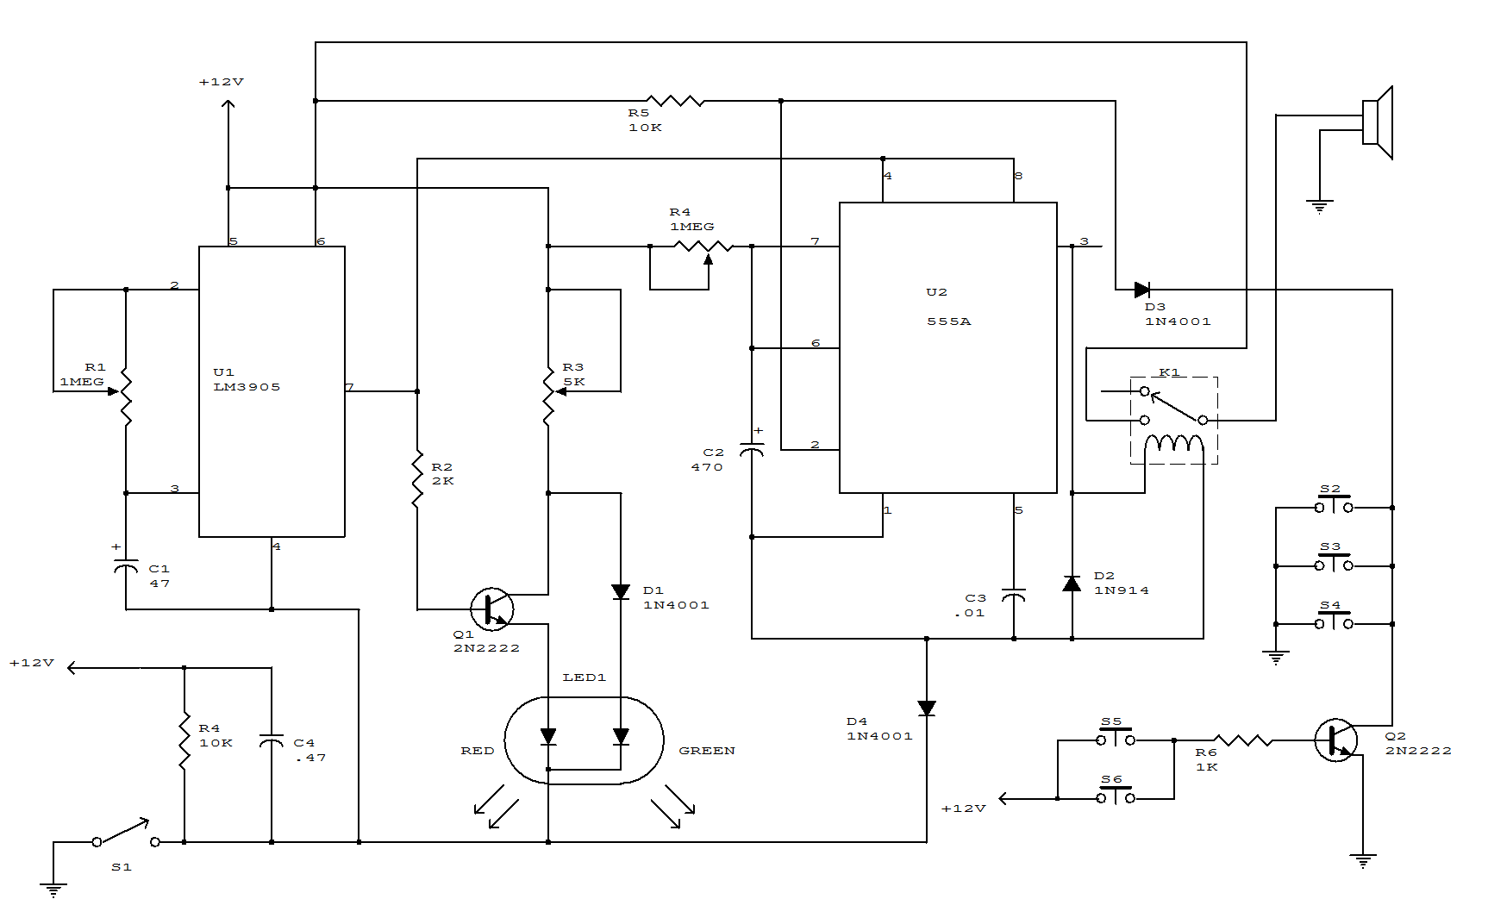

BURGLAR ALARM

The heart of the circuit is a 555 oscillator/timer, U1, configured for monostable operation. The output of U1 at pin3 is tied to the gate of SCR1. As long as S1 - S5, which are connected to the trigger input of U1, are open, the circuit remains in the ready state, and does not trigger SCR1 into conduction. Because the relay is not energized, battery current is routed through the relay's normally-closed terminal and through current- limiting resistor R3 to LED2, causing it to light.
However, when one of the switches (S1 - S5) is closed, grounding U1 pin2, the output of U1 at pin 3 increases, activating SCR1. That energizes the relay, pulling the wiper of K1 to the normally-open terminal, causing LED1 to light and BZ1 to sound.
The duration of the output is determined by the RC time-constant circuit, formed by R1 and C1. Resistor R2 regulates the output of U1 to a safe value for the gate of SCR1. Switches S1 - S5 are to doors, windows, etc. A switch can be connected in series with B1 to activate and deactivate the alarm circuit when it's not needed.

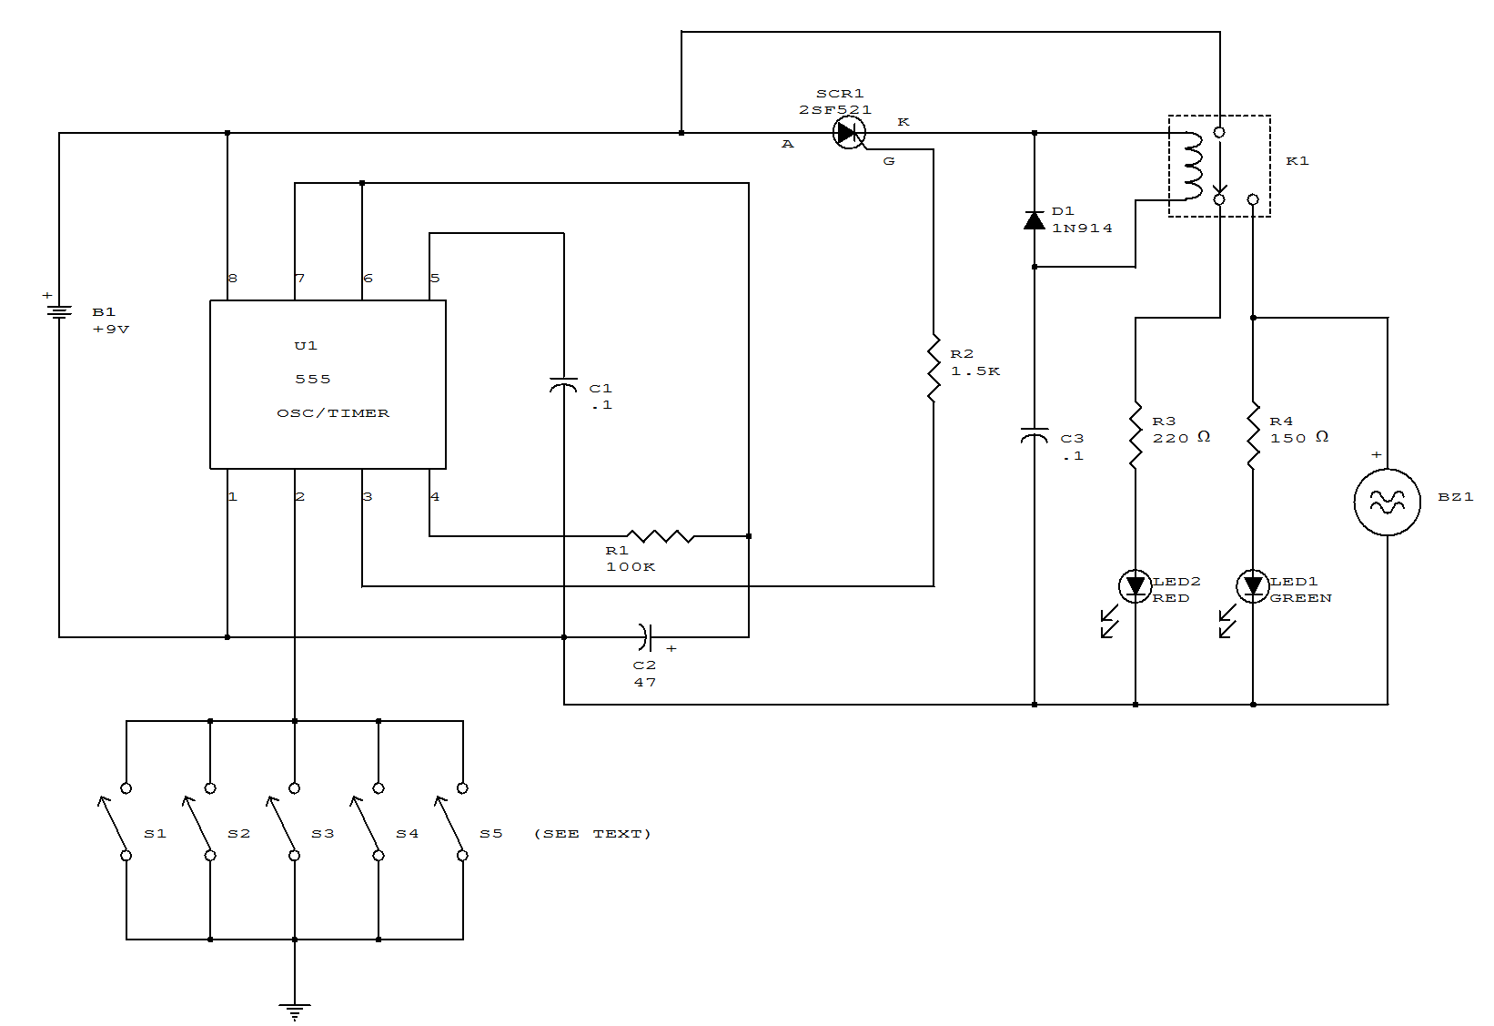

BURGLAR ALARM WITH TIMED SHUTOFF

When S1 (sensor) is closed, power is applied to U2, a dual timer. After a time determined by C2, C1 is energized after a predetermined time determined by the value of C5, pin 9 of U2 becomes low, switching off the transistor in the optoisolater, cutting anode current of SCR1 and de-energizing K1. The system is now reset. Notice that (R6xC2) is less than (R7xC5).
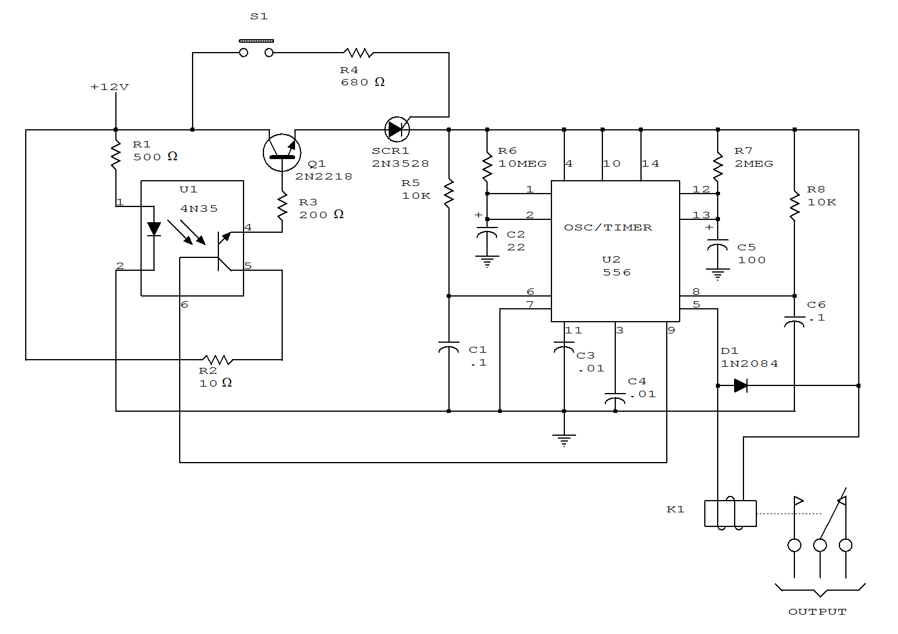

DIFFERENTIAL VOLTAGE OR CURRENT ALARM

The input may be dc or low frequency ac. The output is a distinctive series of audio beeps or a continuous tone, and occurs only when a selected polarity unbalance is present at the input.
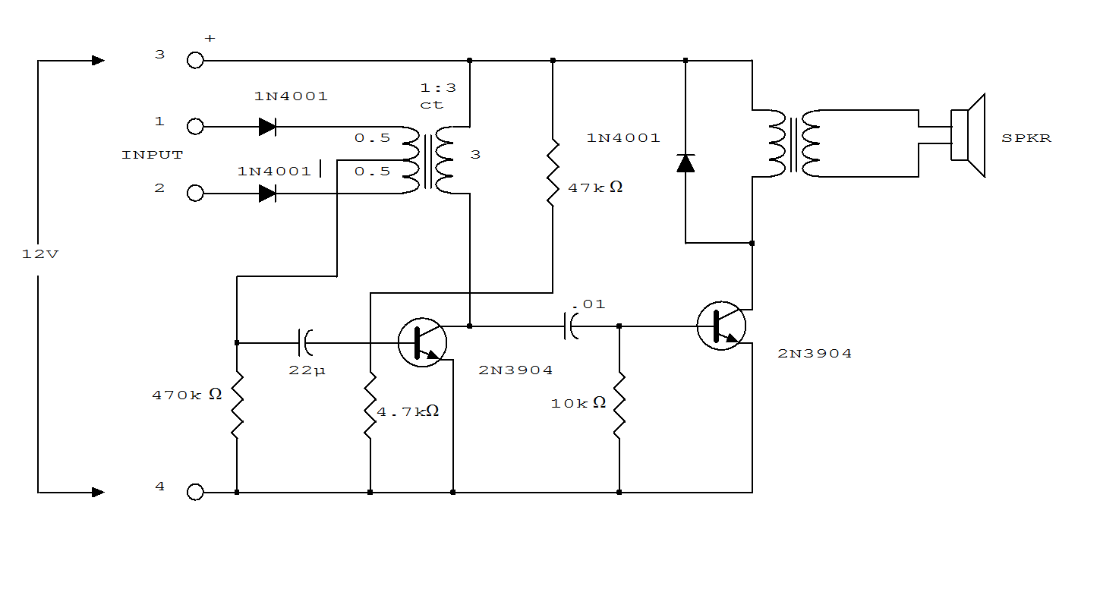
DOOR MINDER

This circuit monitors a door to determine if it has been left open. After 24 seconds, the alarm sounds. S1 is a magnetic sensor. The alarm is an electronic chime sounds that is struck once per second.

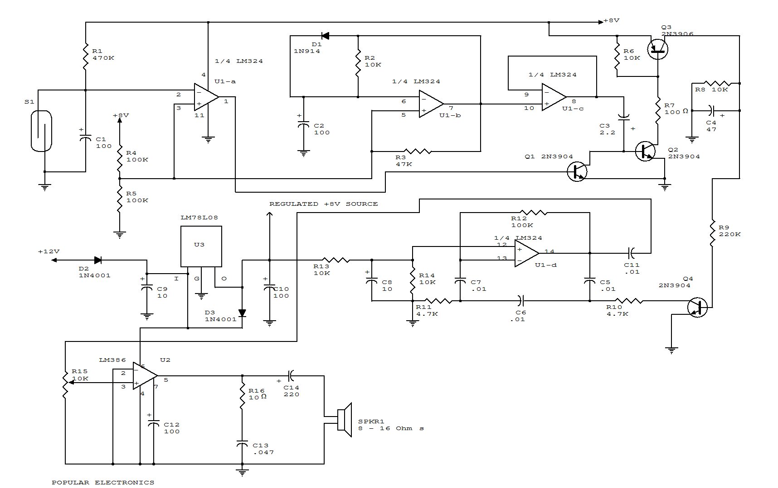

HIGH-POWER ALARM DRIVER

In this circuit, a low-powered SCR is used to trigger a higher powered SCR. When a switch is opening (S2, S3, S4) or closing (S5, S6, S7), either SCR1 or SCR2 triggers. This triggers SCR3 via D1, D2, and R5. BZ1 is a high-powered alarm of the noninterrupting type.
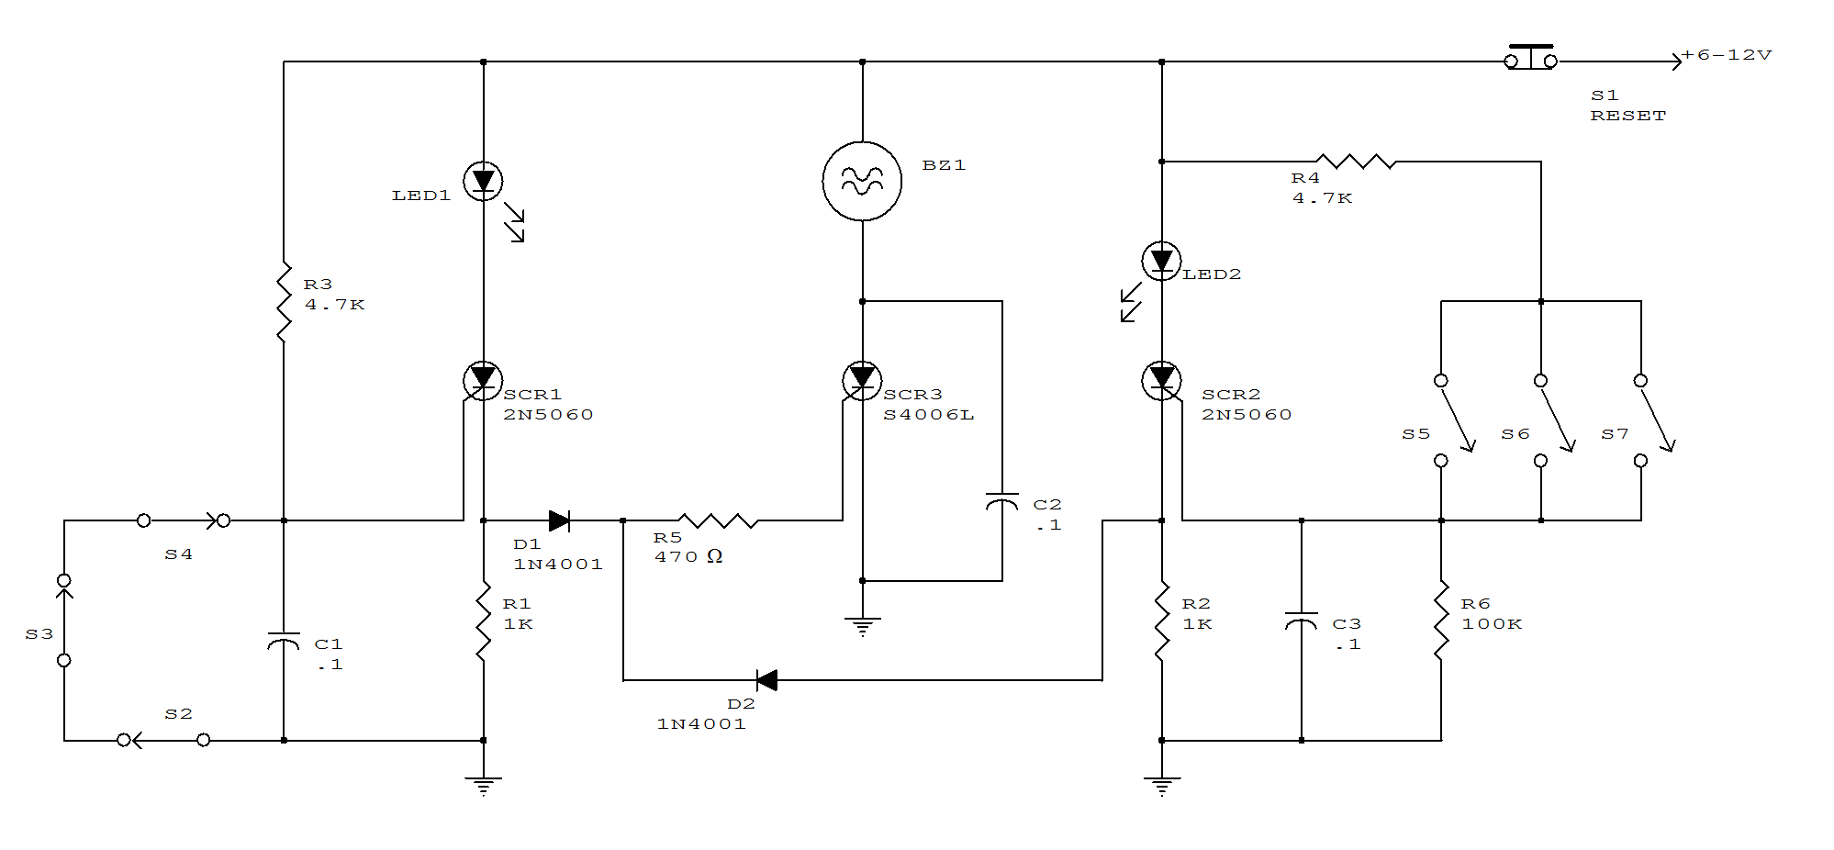
HOME SECURITY SYSTEM

This alarm circuit activates when S1 through S5 are activated. This lights LED1 and activates Q1 via IC1C and IC1D. RY1 is wired to self latch. S10 is used to reset. When key switch S1 is activated or when re-entry buttons at S6 are depressed, IC1C is deactivated until RC network R7/C3 charges.
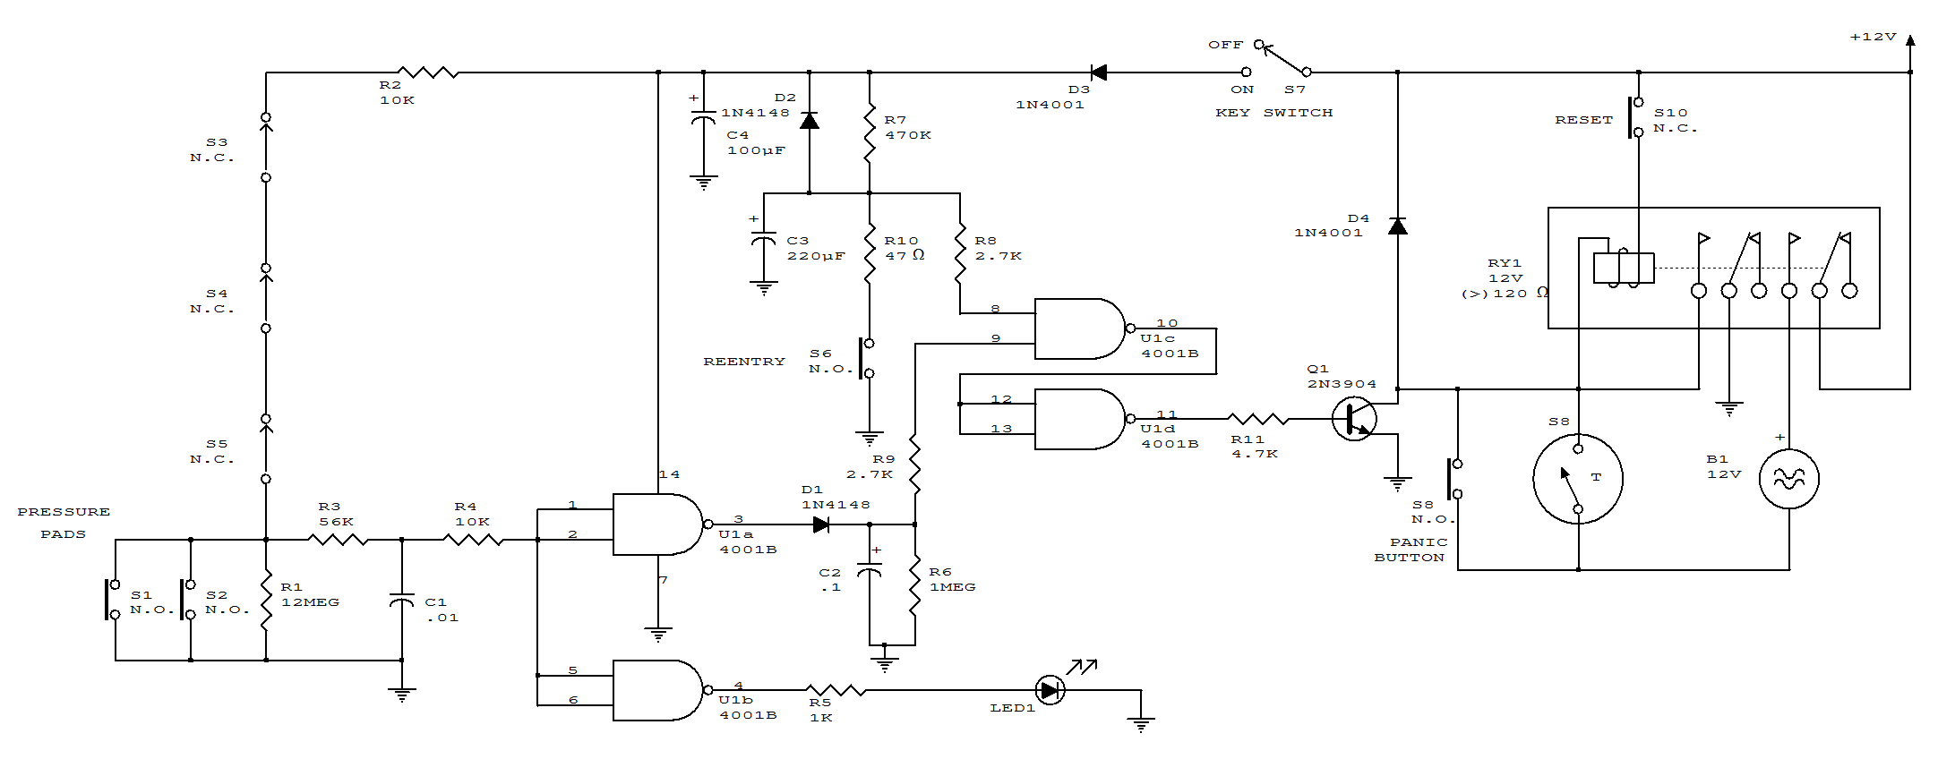
LATCHING BURGLAR ALARM

When the protective circuit is interrupted (opened), the alarm sounds. To set the circuit, adjust R2 (with protective circuit open) for 1 V across R1.

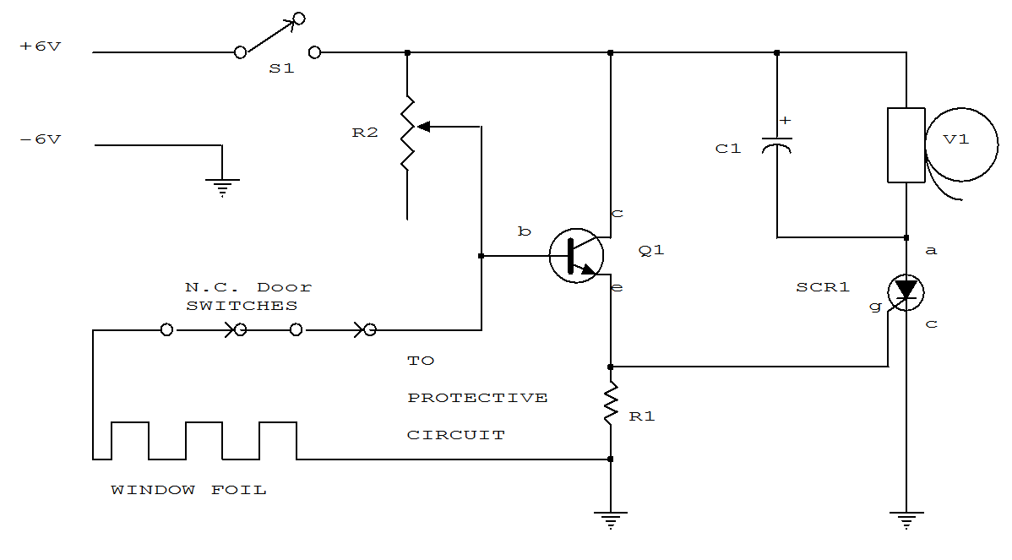
LIGHT-BEAM ALARM FOR INTRUSION DETECTION
When the light beam that falls in the CDS photocell is interrupted, transistor (2N3904) conducts thereby triggering SCR1 (C106) and activating alarm bell. S1 resets the SCR. The alarm bell should be a self-interrupting electro-mechanical type.
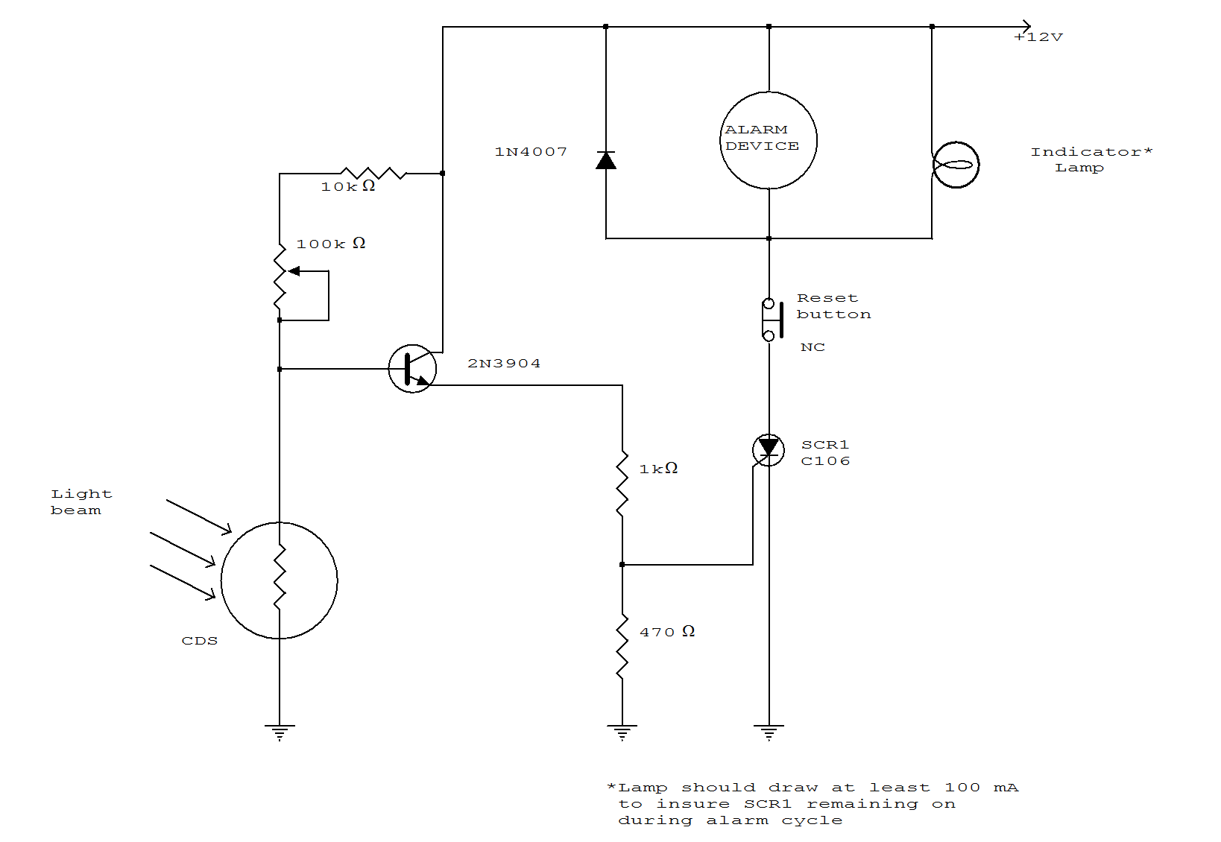
LIGHT-BEAM ALARM PREAMP
This circuit can be used for light beams to 20kHz. The gain of the operational amplifier is set for a 40-dB gain.
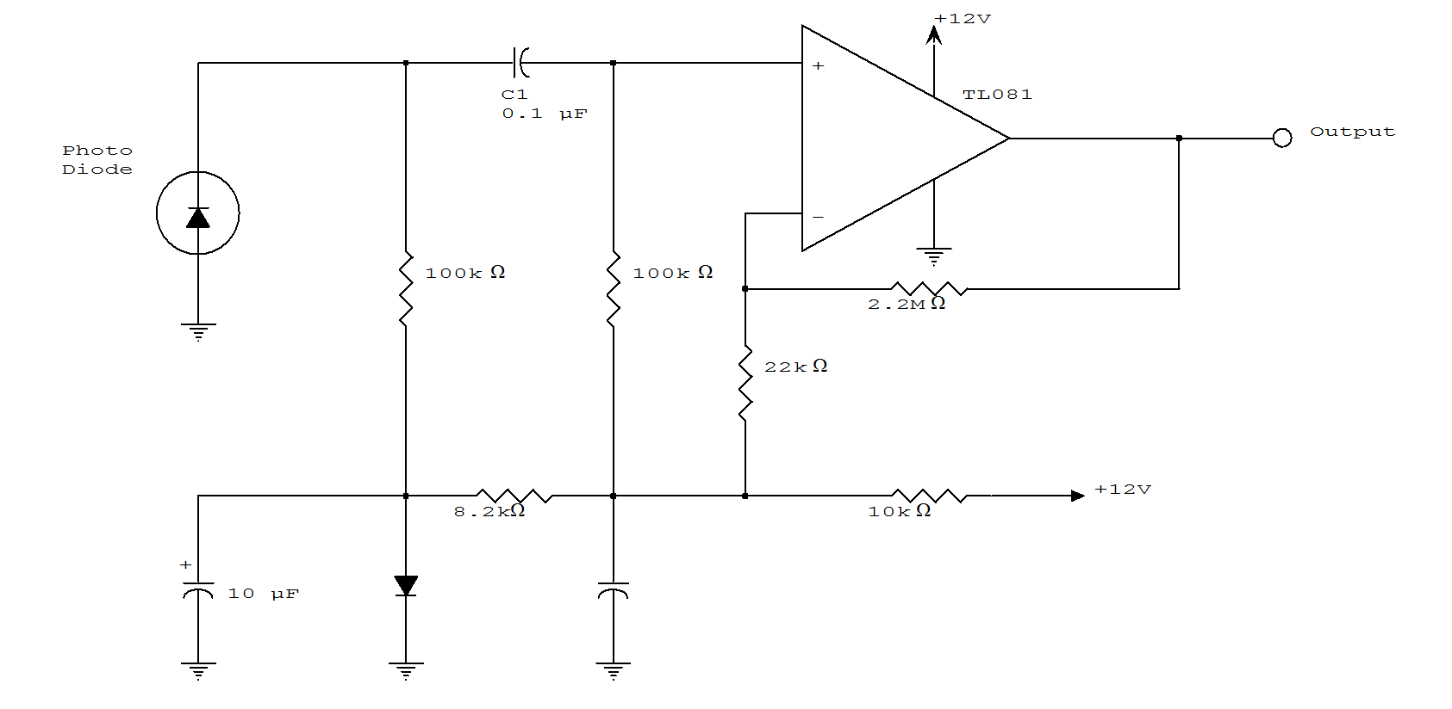

SELF-LATCHING LIGHT ALARM WITH TONE OUTPUT
A decrease in the resistance of the CDS cell when light strikes it activates latch a and b, enabling tone oscillator c and d which produces an output of about 1000 Hz. RA sets the trip level. S1 resets the circuit.
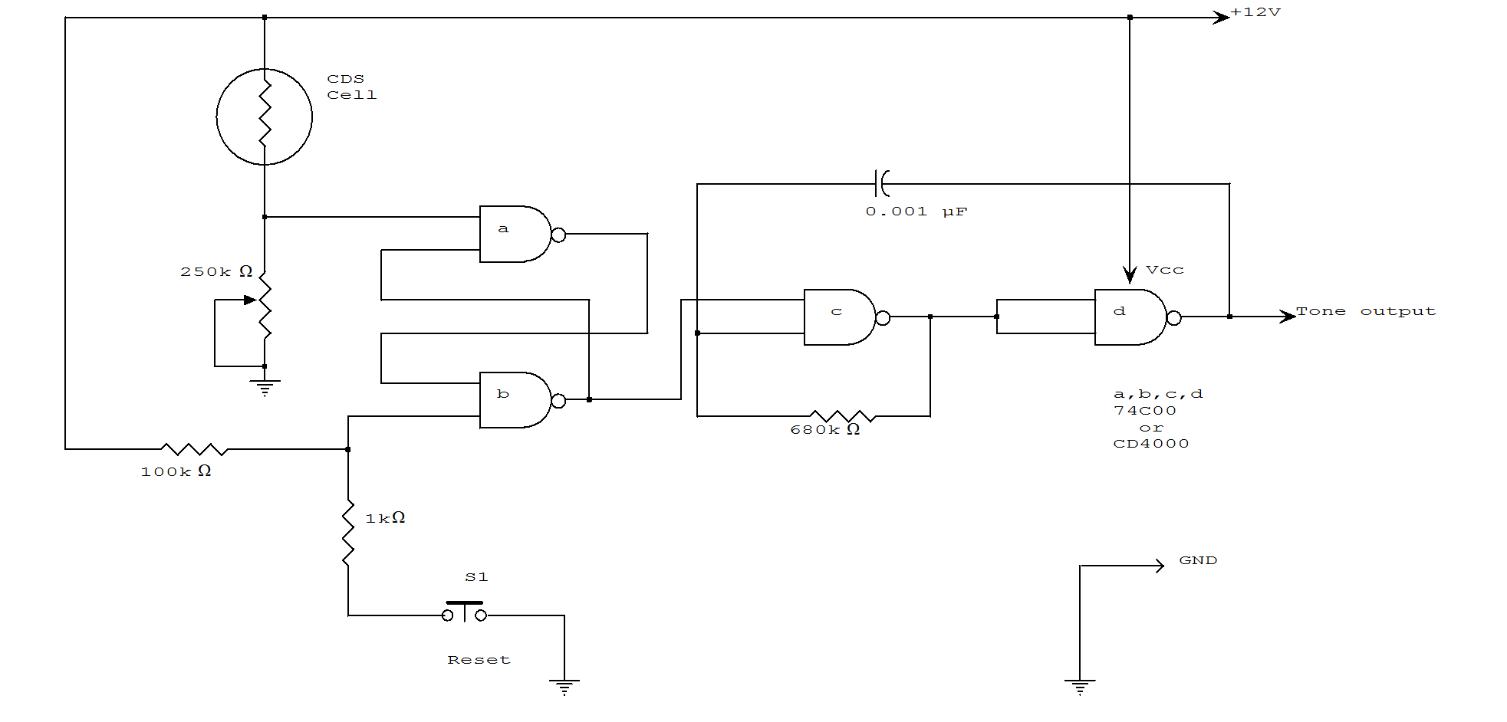
SECURITY ALARM

This alarm features open- and closed-loop detector and automatic alarm shutoff. Offers 15 second exit/entrance delay. Alarm on time can be adjusted from 1 to 15 minutes.
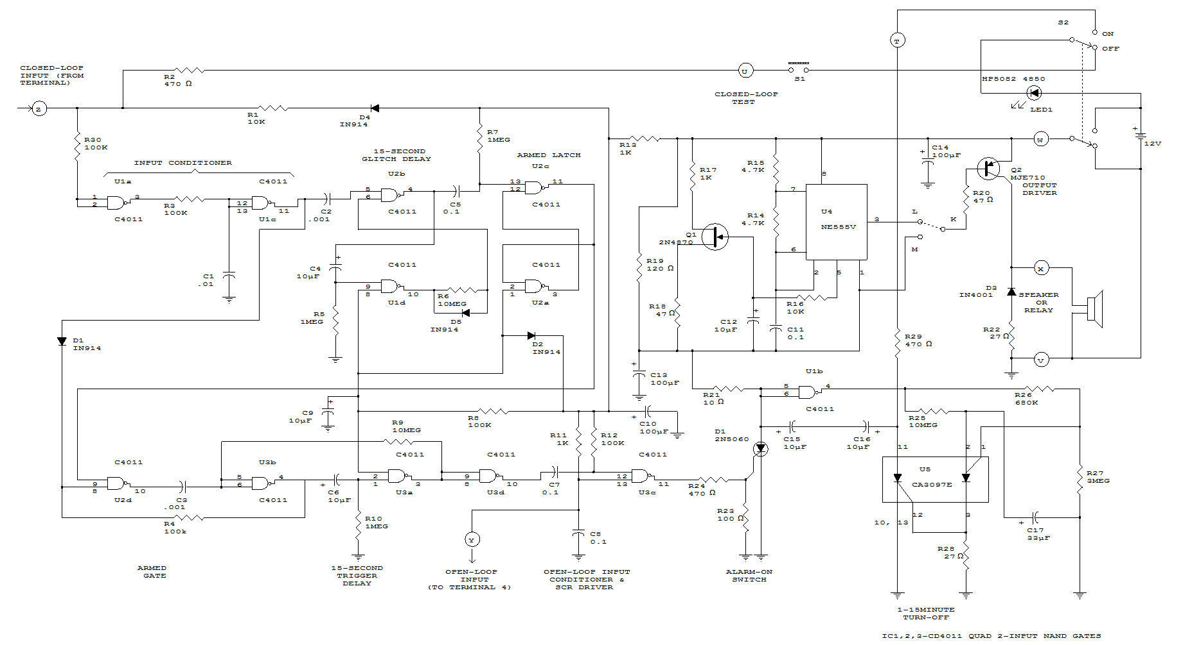
SERIES/PARALLEL LOOP ALARM
Two SCRs are used with two sensor loops. One loop uses series switches, the other loop parallel switches. When a switch actuation occurs, the SCR triggers. The alarm should be a noninterrupting type.
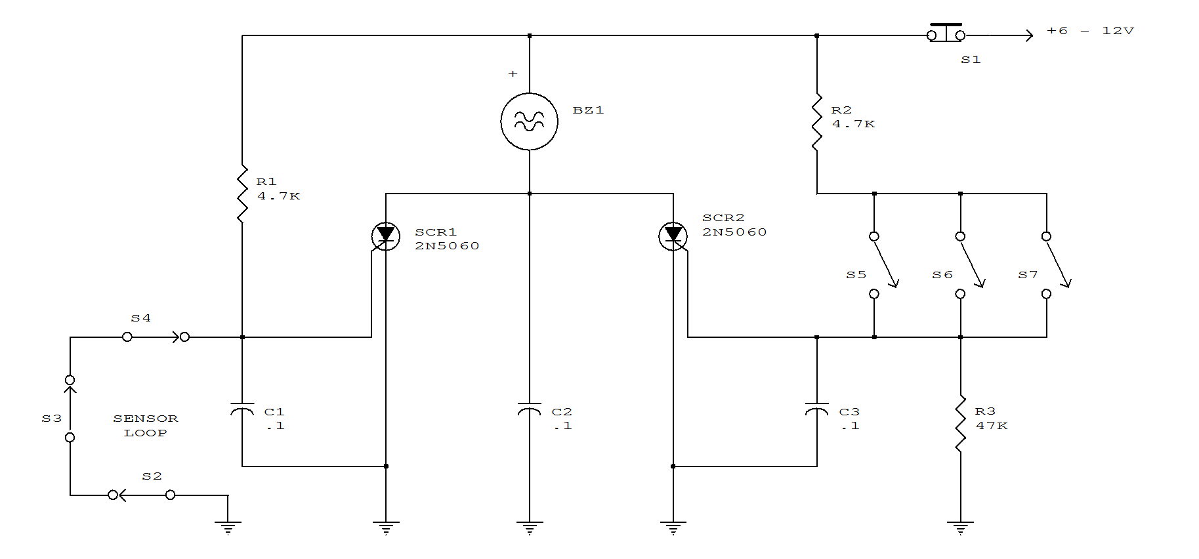
VEHICLE SECURITY SYSTEM
This alarm gives a 15-20 second exit and entrance delay. After being triggered, the alarm sounds for five minutes and then shuts off. Once triggered, the sequence is automatic and is not affected by subsequent opening or closing of doors.
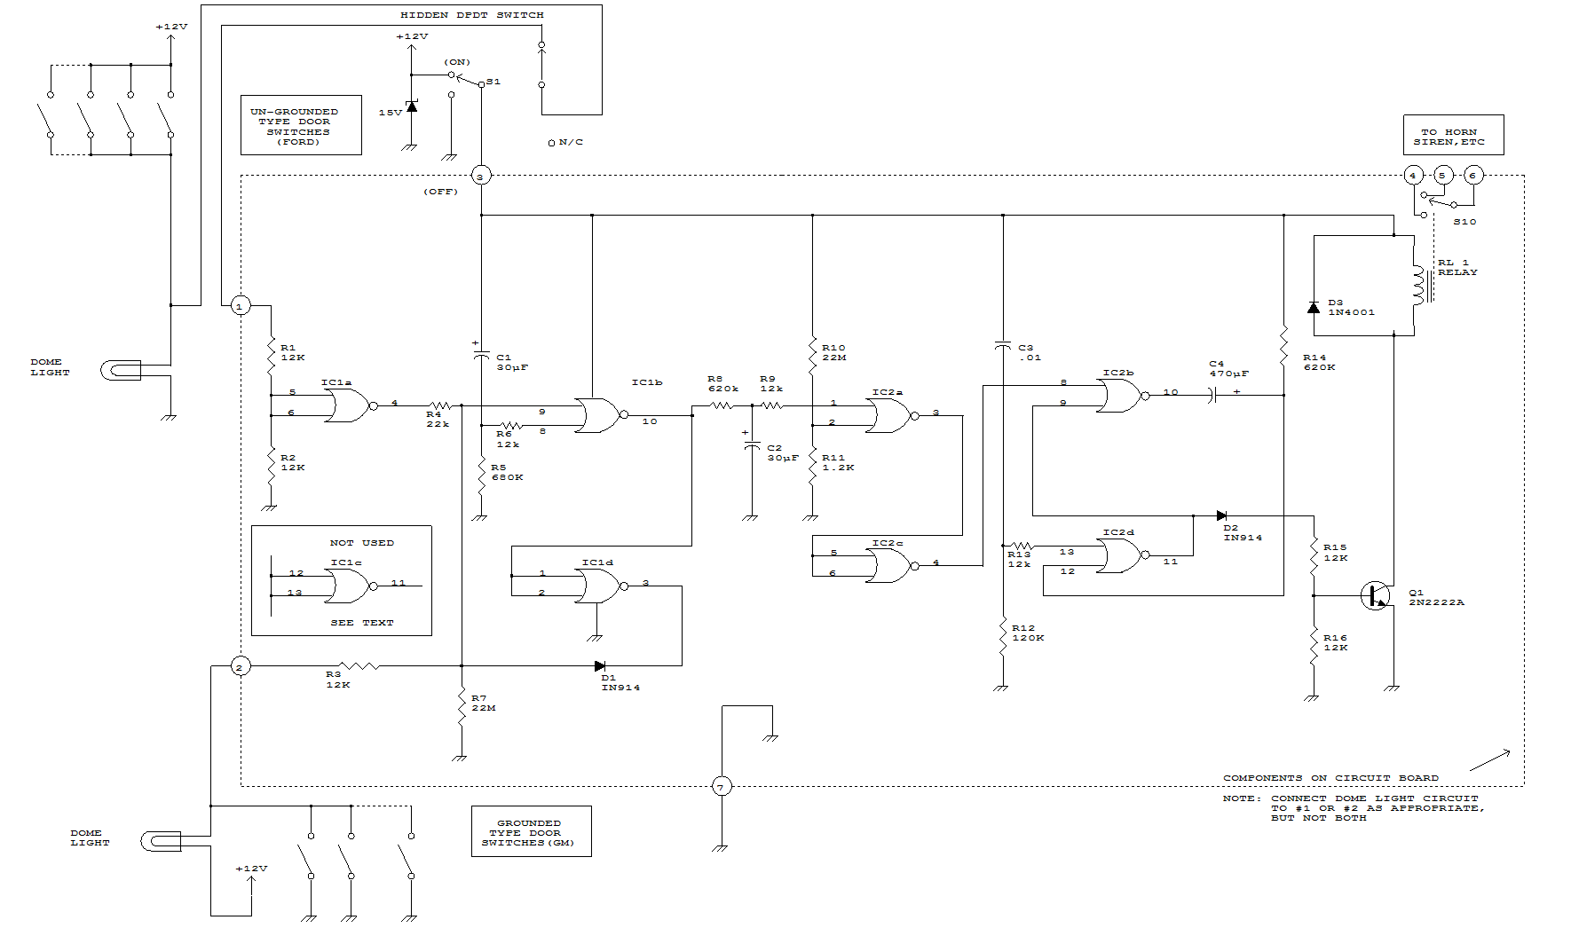

AUTOMATIC TAPE RECORDING

Amateurs don't have to miss the action while away from the rig. This circuit turns on a tape recorder whenever the receiver's squelch is broken. After signal loss, the recorder will shut off following a slight delay. 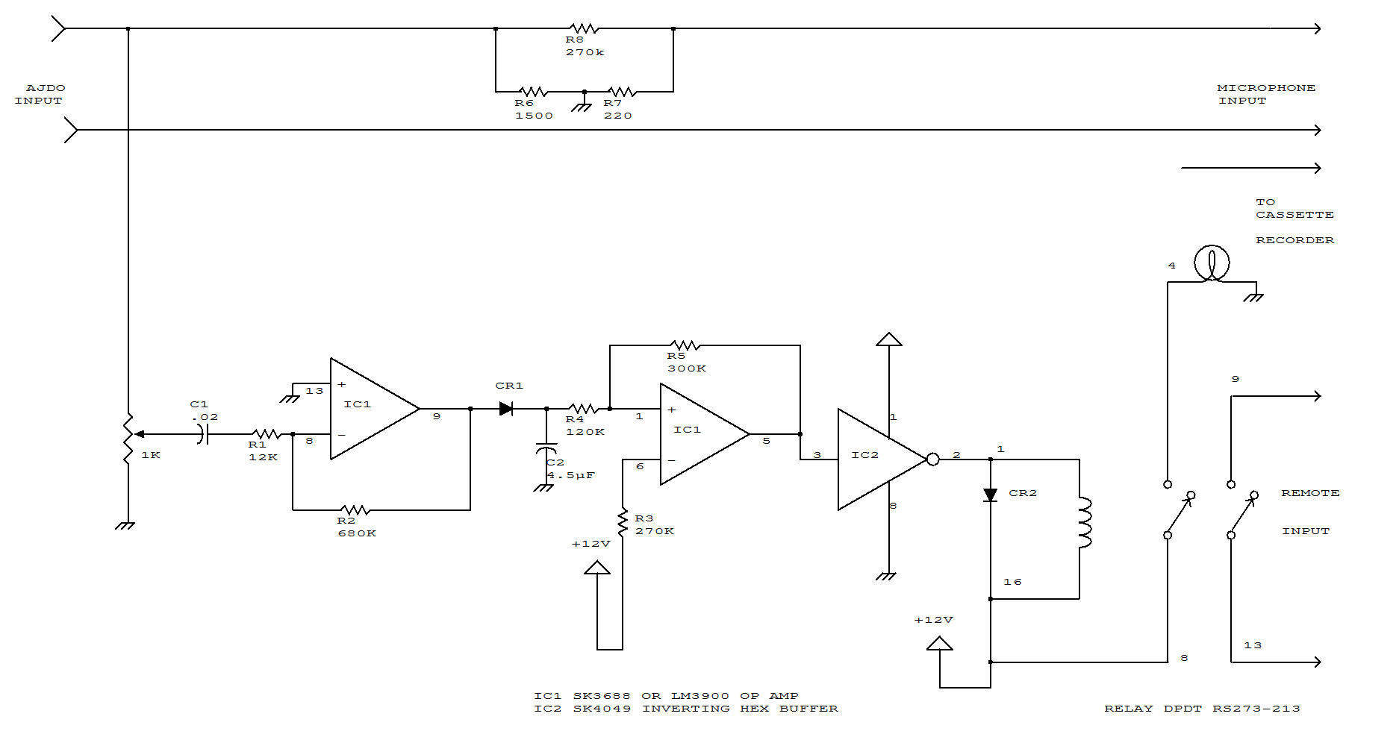

SUB-AUDIBLE TONE ENCODER
This twin-T oscillator produces six preset sub-audible tones from 93 to 170 Hz in three ranges.
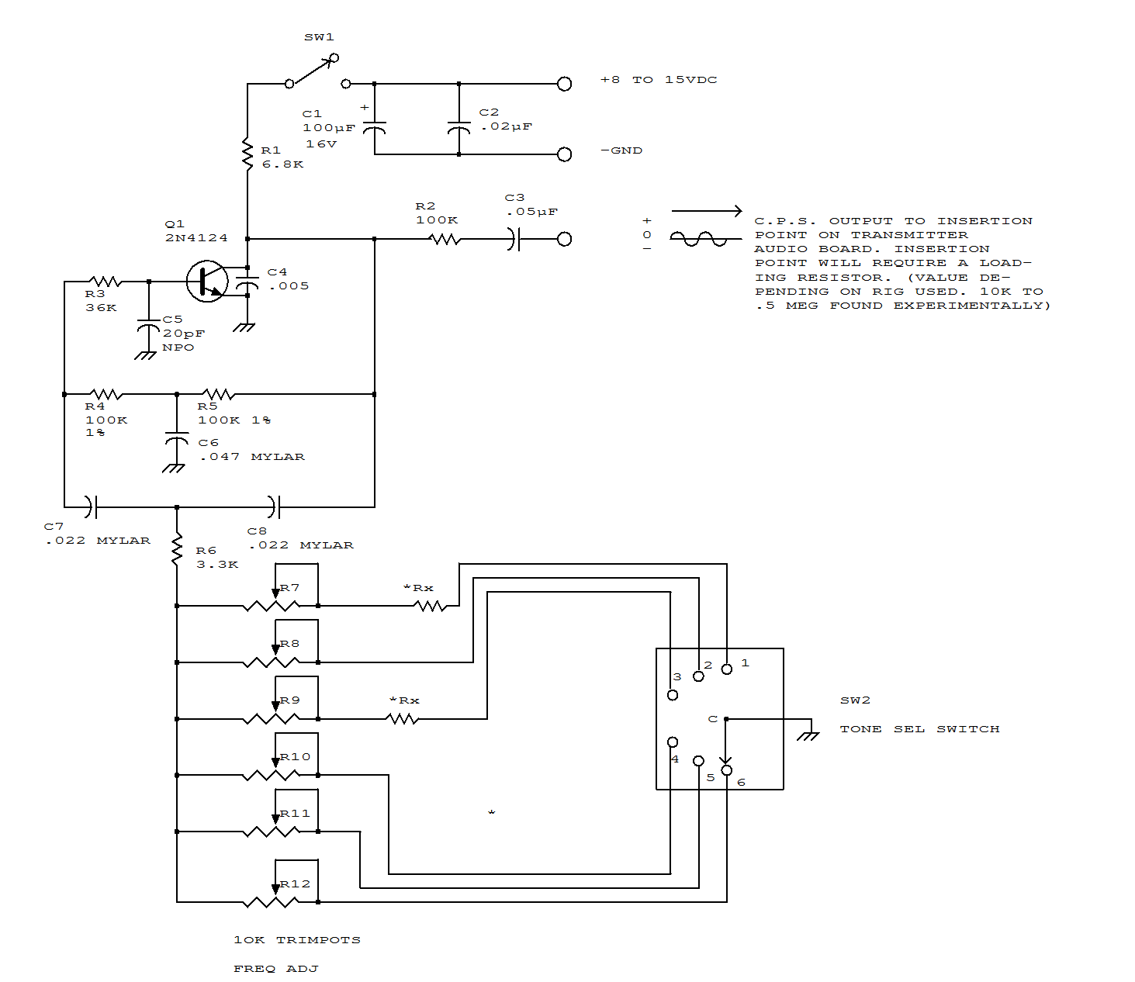
20-DB AUDIO BOOSTER
The amplifier's gain is nominally 20 dB. Its frequency response is determined primarily by the value of just a few components-primarily C1 and R1. The values in the schematic diagram provide a response of 3.0 dB from about 120 to over 20,000 Hz. Actually, the frequency response is flat from about 170 to well over 20,000 Hz; it's the low end that deviates from a flat frequency response. The low end's rolloff is primarily a function of capacitor C1, since R1's resistive value is fixed. If C1's value is changed to 0.1 mF, the low end's corner frequency-the frequency at which the low end rolloff starts--is reduced to about 70 Hz. If you need an even deeper low end rolloff, change C1 to a 1.0-mF capacitor. If it's an electrolytic type, make certain that it's installed into the circuit with the correct polarity--with the positive terminal connected to Q1's base terminal.
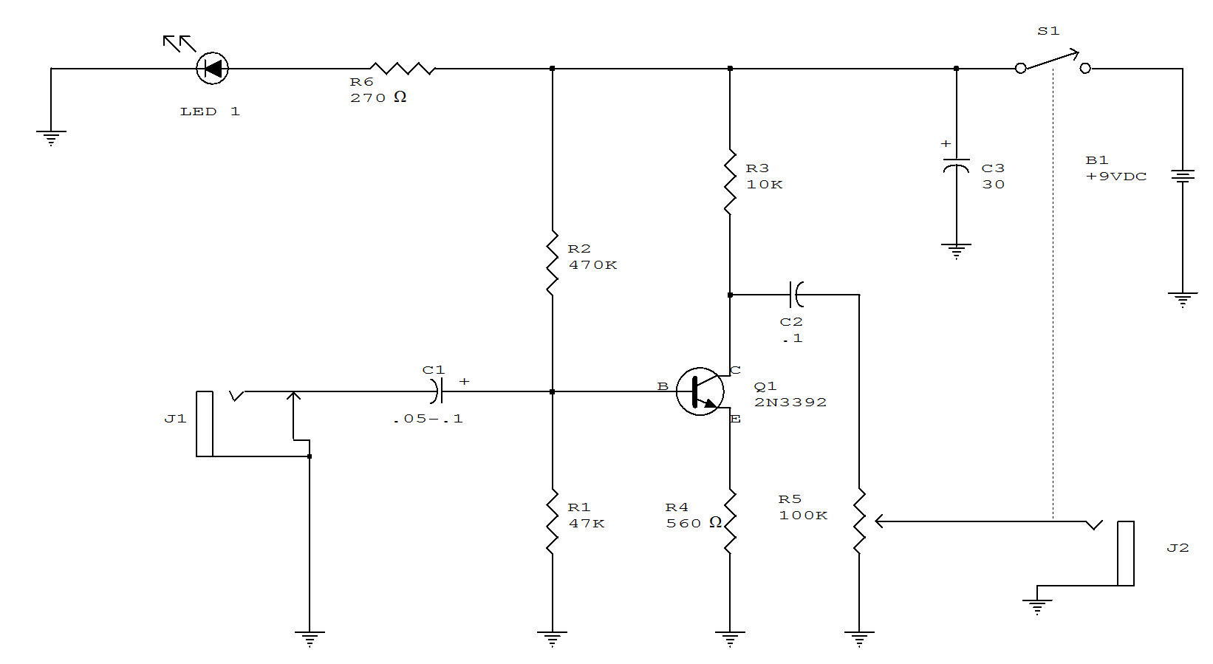

DC-STABILIZED FAST AMPLIFIER
This amplifier functions over a wide range of gains, typically 1 - 10. It combines the LT1010 and a fast discrete stage with an LT1008 based dc stabilizing loop. Q1 and Q2 form a differential stage which single-ends into the LT1010. The circuit delivers 1 V pk-pk in to a typical 75-ohm video load. At A = 2, the gain is within 0.5 dB to 10 MHz with the -3-dB point occurring at 16 MHz. At A = 10, the gain is flat(plus or minus 0.5 dB to 4 MHz) with a -3-dB point at 8 MHz. The peaking adjustment should be optimized under loaded output conditions. This is a simple stage for fast applications where relatively low output swing is required. Its 1 V pk-pk output works nicely for video circuits. A possible problem is the relatively high bias current, typically 10 uA. Additional swing is possible, but more circuitry is needed.
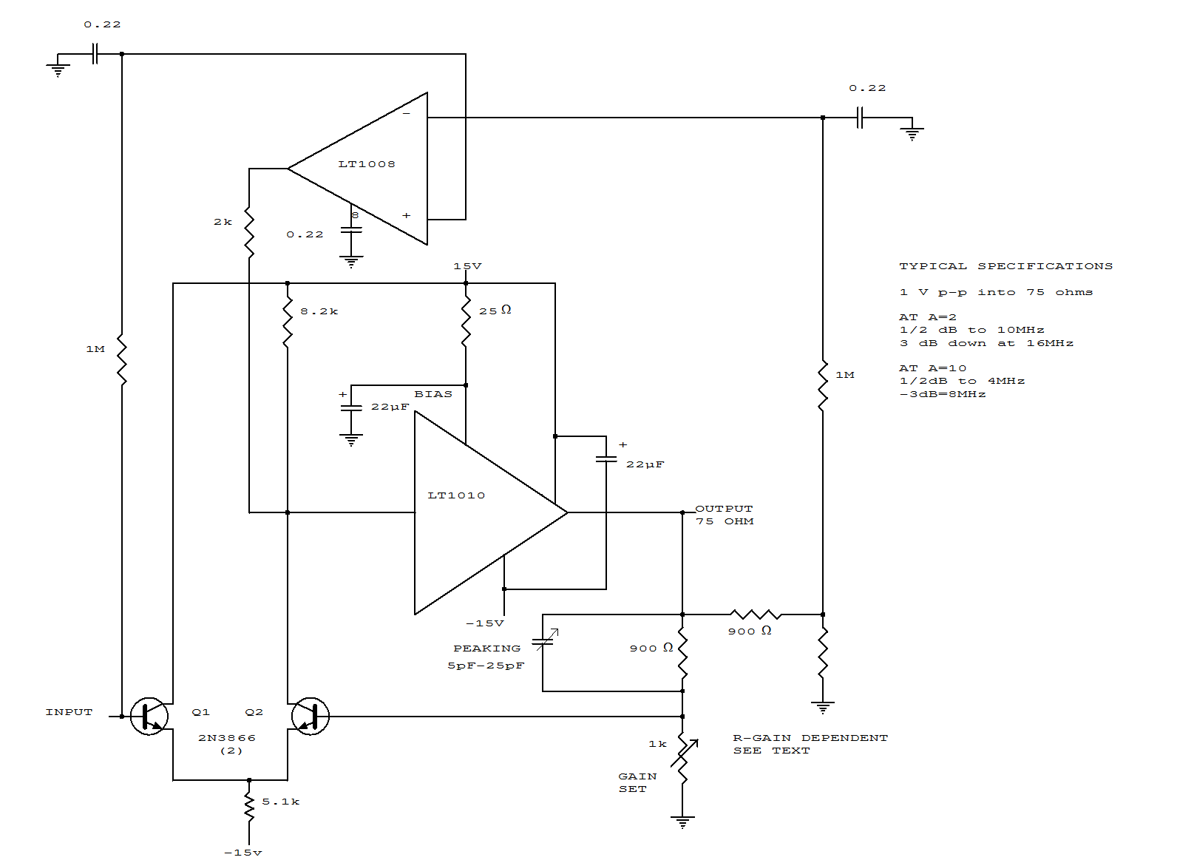
DISCRETE CURRENT BOOSTER
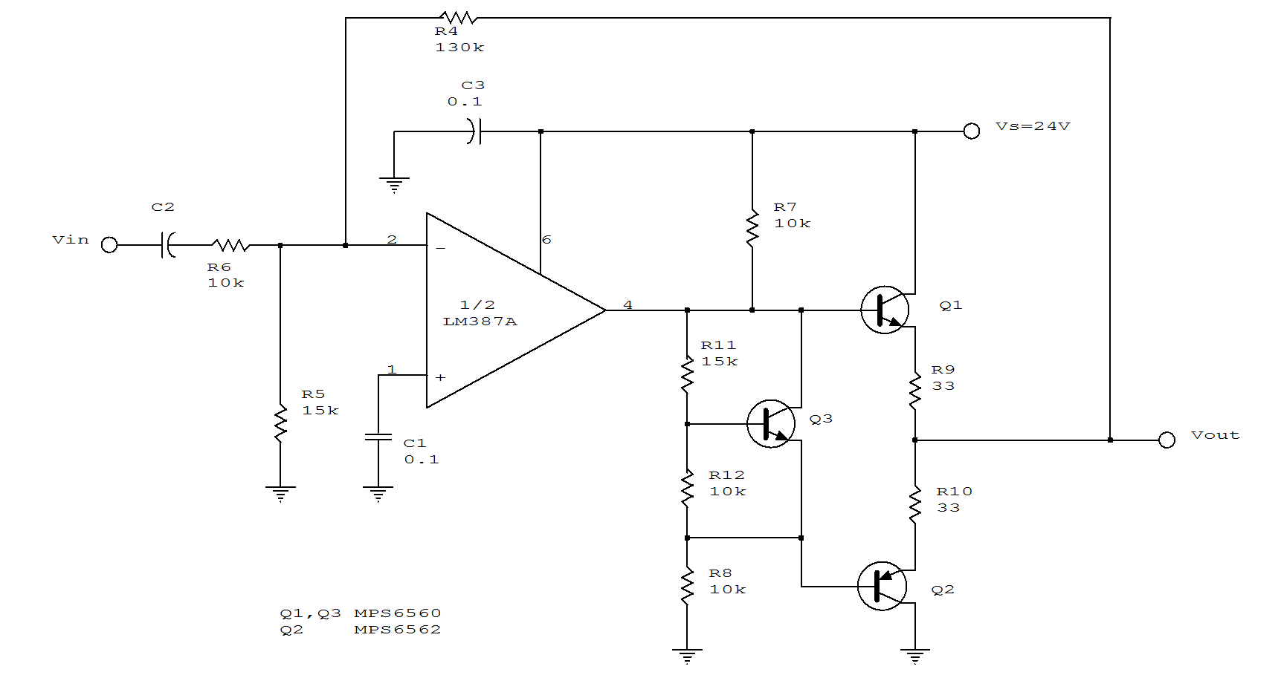

GENERAL-PURPOSE PREAMPLIFIER

Suitable for general audio use, the preamp circuit uses a feedback pair. Current gain is set by the ratio of (R4+R6)/R4.
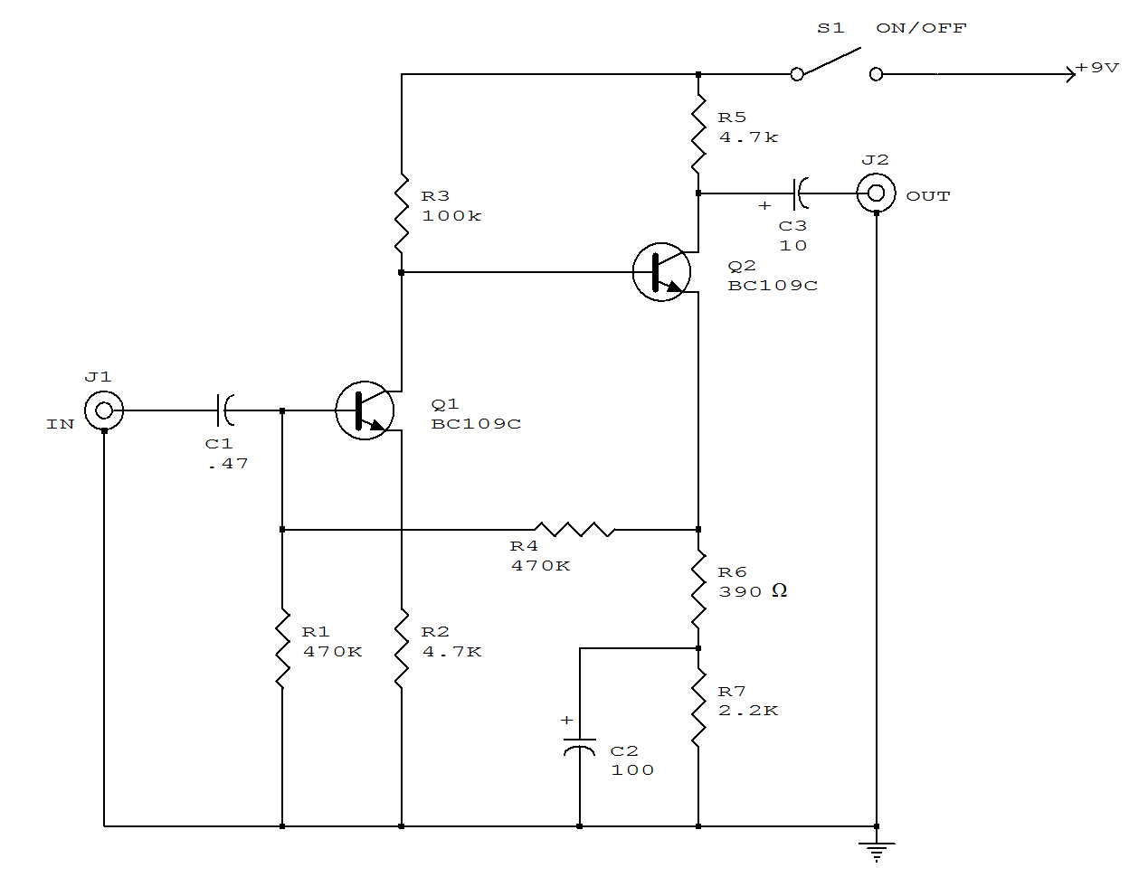

MICRO-SIZED AMPLIFIER
Sound detected by electret microphone MIC1 is fed to IC1's input through resistor R2, and capacitors C1 and C2. Resistors R2 and R5 determine the overall stage gain, while C2 partially determines the amplifier's frequency response. To ensure proper operation, use a single-ended power supply. R3 and R4 simulate a null condition equal to half the power supply's voltage at IC1's noninverting input. The output of IC1 is transferred to emitter-follower amplifier Q1 via volume control R6. The high-Z-in/low-Z-out characteristic of the emitter-follower matches the moderately high-impedance output of IC1 to a low-impedance headphone load.
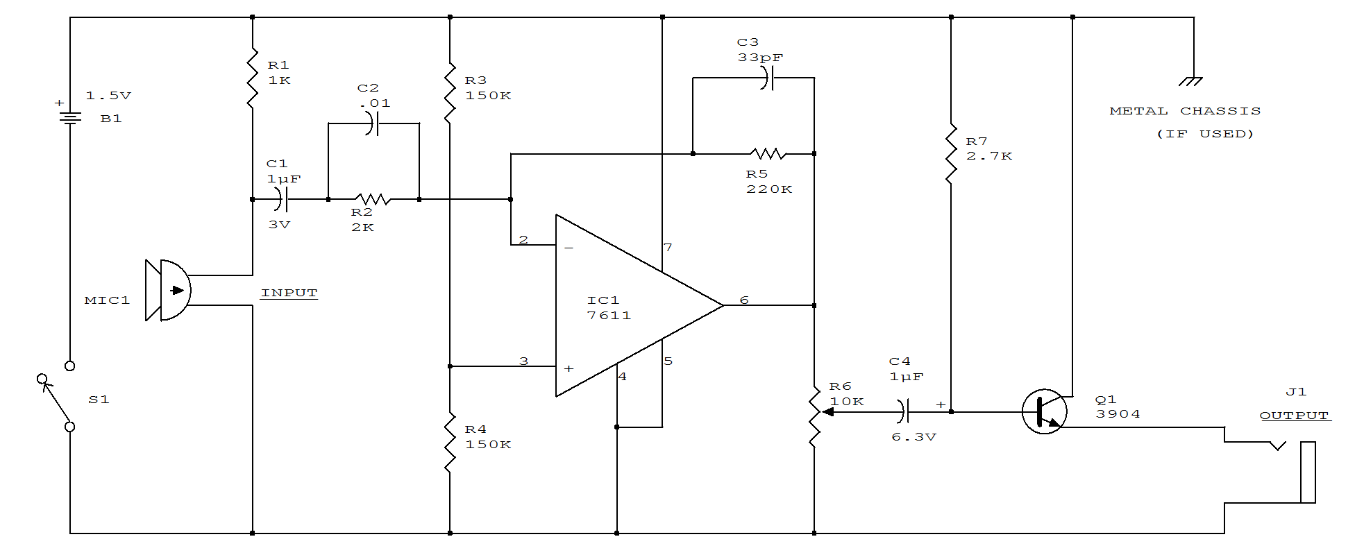

MINI-STEREO
This circuit is built around two chips: the MC1458 dual op amp, configured as a preamplifier, and the LM378 dual 4-watt amplifier. The gain of the preamp is given by R3/R1 for one side and R4/R2 for the other side, which is about 100.
That gain can be varied by increasing the ratios. The left and right channel inputs are applied to pin 2 and 6. The left and right outputs of U1 at pins 7 and 2 are coupled through C5/R10 and C3/R6, respectively, to U2 to drive the two 8-W loudspeakers.
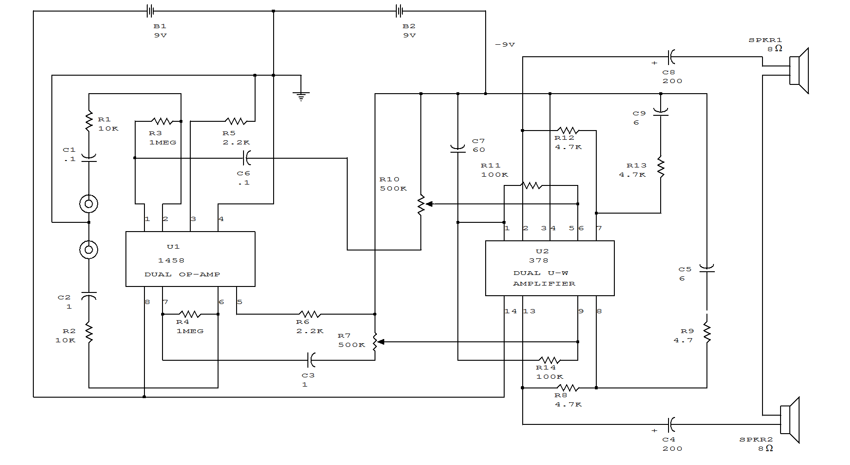

SPEAKER AMPLIFIER FOR HAND-HELD TRANSCEIVERS

The LM383 is an audio-power amplifier that is capable of producing up to 8 W of audio output. R1 is essentially a load resistor for the hand-held transceiver's audio output. R2 can be composed of two fixed resistors in a 10:1 divider arrangement, but using a potentiometer makes it easy to set the amplifier's maximum gain. When powered from a vehicle's electrical system, the amplifier's +12V power source requires filter L1 to eliminate alternator whine. The LM383 can be mounted directly on the heatsink because the mounting tab is at ground potential.
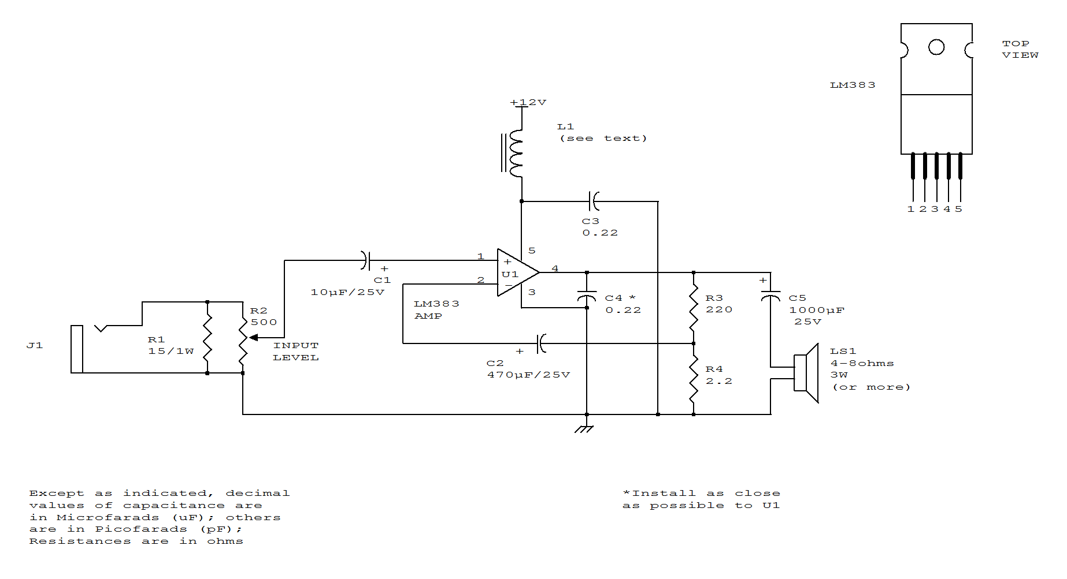

LOW-COST CHIME CIRCUIT

Resistor R1, capacitor C1, and two inverters from a square wave generator, which produces the basic tone. The generator is followed by an inverter that acts as both a buffer and a driver for the speaker. Resistor R2, which has a minimum value of 100 ohms, limits the current and controls the volume. Diode D1, capacitor C2, resistors R3 and R4, and two inverters create the pulse generator that determines the turn-on and decay times of the chime. The decay circuit-formed by D2, C3, R5, and Q-reduces the amplitude of the chime tone exponentially as a function of time.
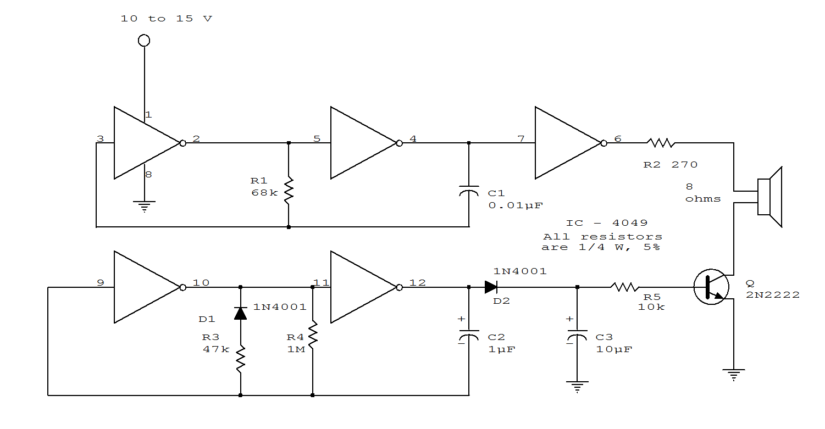

SLIDING-TONE DOORBELL

When the doorbell is pushed, you'll hear a low tone that will "slide up" to a higher frequency. The frequency of the AF oscillator is determined by coupling capacitor, C1 and the value of the resistance connected between the base of Q1 and ground. That resistance, RBG is equal to (R1 + R2) R3. First, assume that S1 is closed and R2 has been adjusted to produce a pleasant, low-frequency tone. Capacitor C3 will charge through R6 until it reaches such a voltage that it will cause diode D1 to conduct. When that happens, the value of RBG is paralleled by R4. Thus, because the total resistance RBG decrease, the output tone slides up in frequency. Capacitor C3 will continue to charge until the voltage across D2 and D3 causes those diodes to conduct. Then RBG is paralleled also by R5, the total resistance again decreases, and the oscillator's frequency again increases.

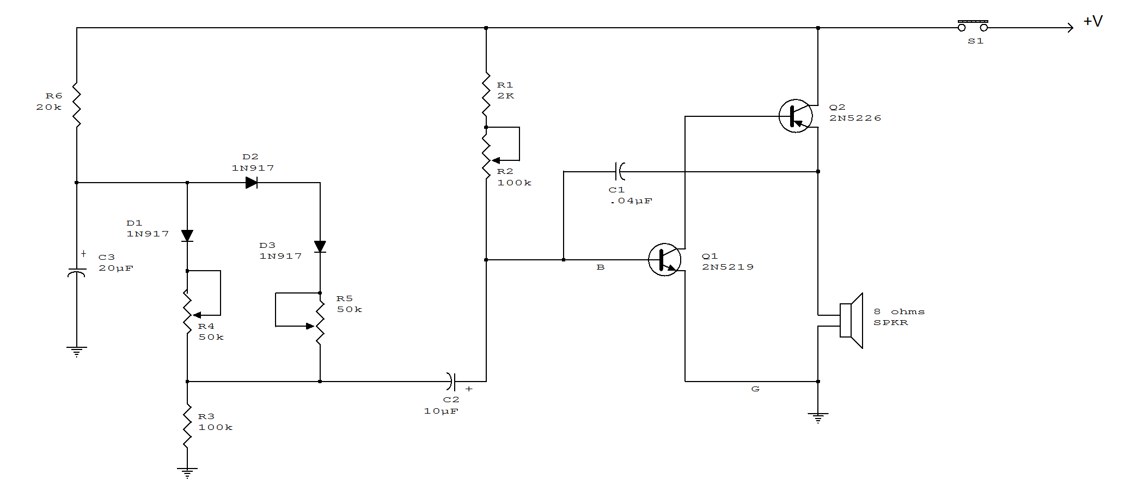

12 W LOW-DISTORTION POWER AMPLIFIER
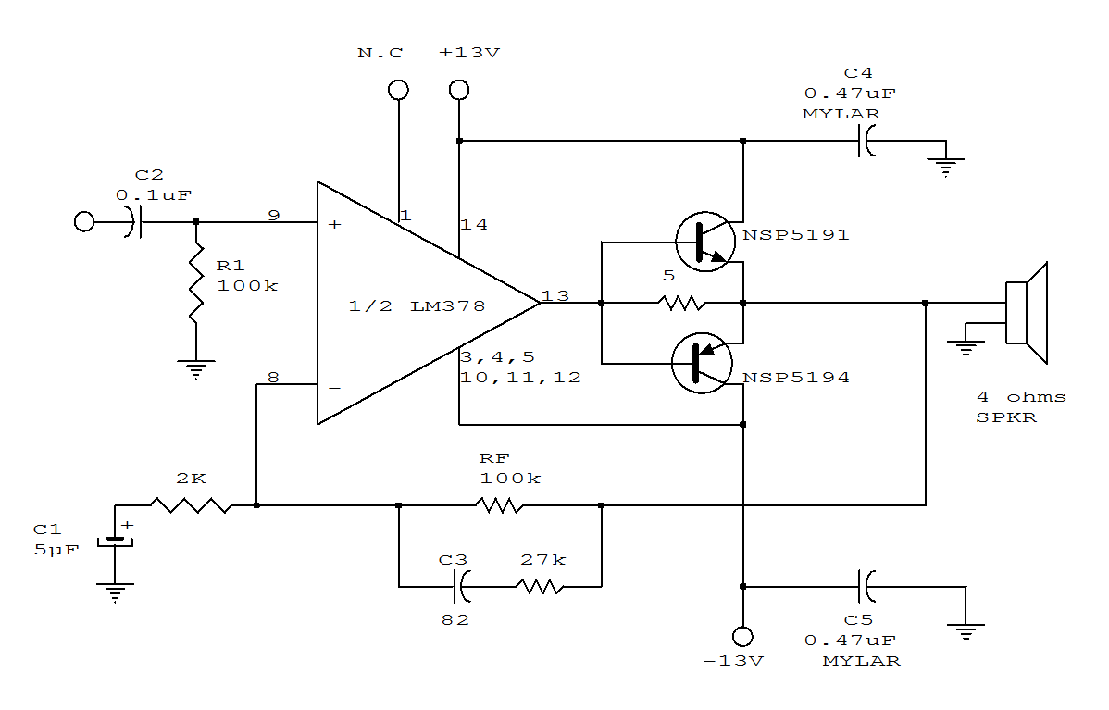
BRIDGE AMPLIFIER

This circuit is for low voltage applications requiring high power outputs. Output power levels of 1.0 W into 4 ohm from 6 V and 3.5 V into 8 ohm from 12 V are typical. Coupling capacitors are not necessary since the output dc levels will be within a few tenths of a volt of each other. Where critical matching is required the 500K potentiometer is added and adjusted for zero dc current flow through the load.
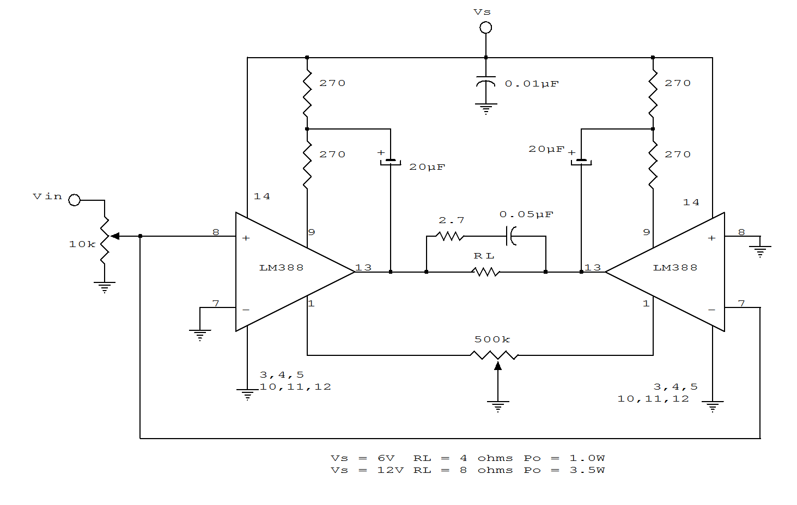
LM380 PERSONAL STEREO AMPLIFIER

With the simple circuit, you can use your personal stereo to drive standard 8 ohm speakers. Use 2 identical circuits to the circuit below:
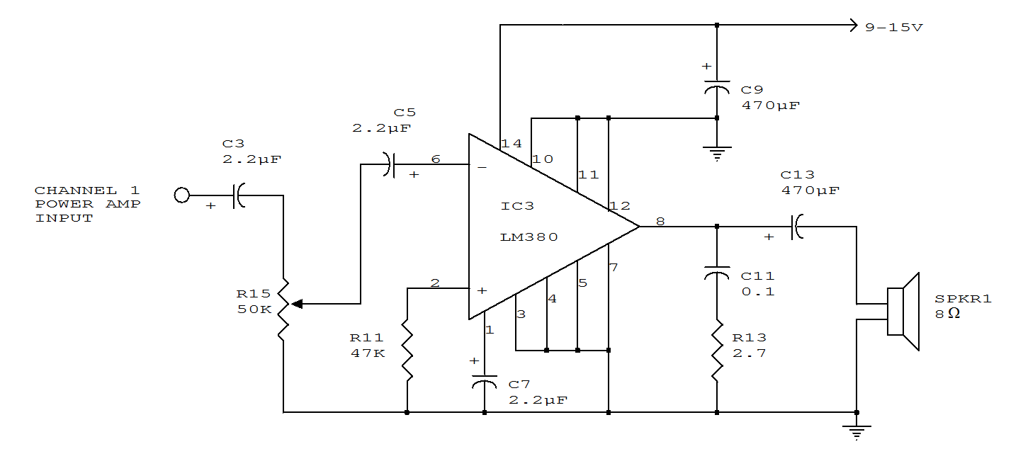

NON-INVERTING AMPLIFIER USING SINGLE SUPPLY
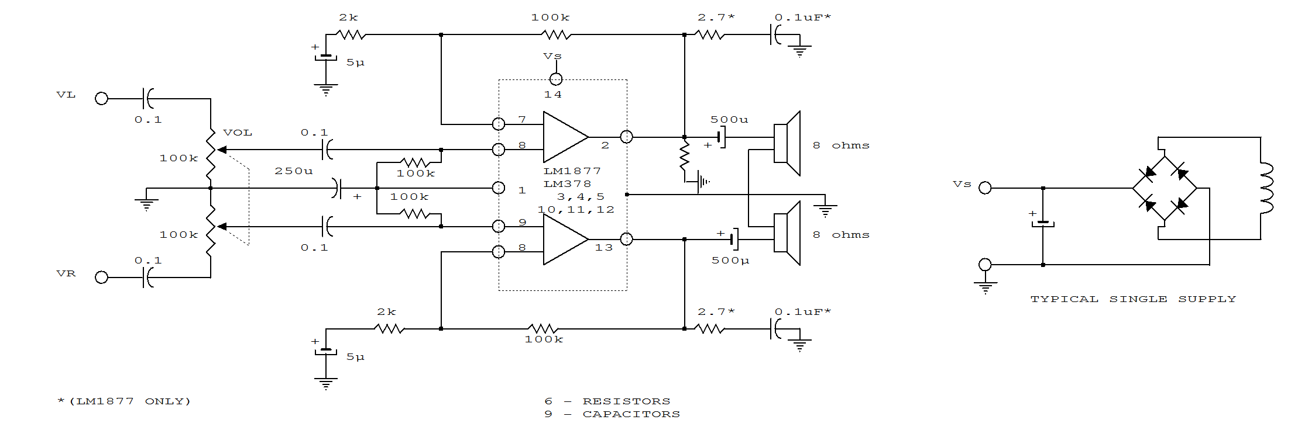
PHONO AMPLIFIER WITH COMMON MODE VOLUME AND TONE CONTROL
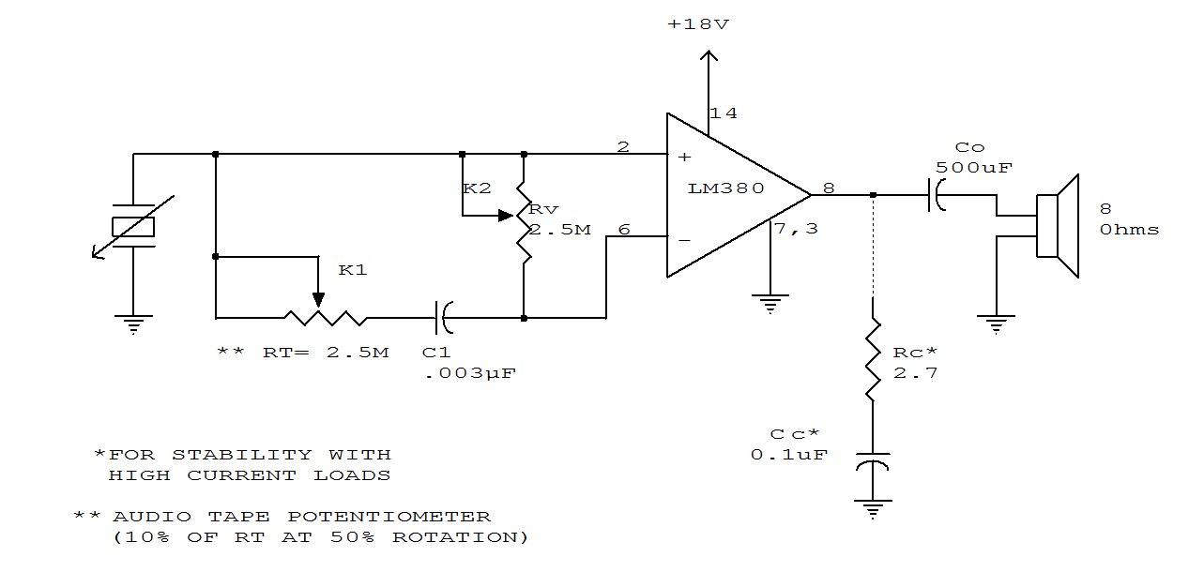

AUDIO DISTRIBUTION AMPLIFIER

Three low-Z audio outputs are available from this circuit, using a quad TL084 FET amplifier. The input is high impedance. Vcc can be 6 to 12 V for typical applications.
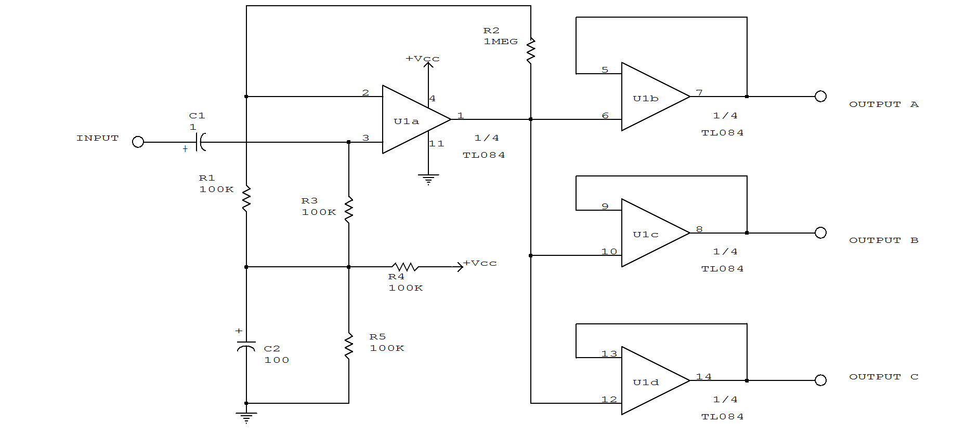

GENERAL-PURPOSE PREAMP

This amplifier is useful for audio and video applications. Gain is set by Rf and the voltage gain of this amplifier is approximately 1+Rf/560, where Rf is in ohms. Bandwidth depends on gain selected, but typically it is several MHz. Rf=5.1 kW, which produces a gain of 10*(20dB) voltage.
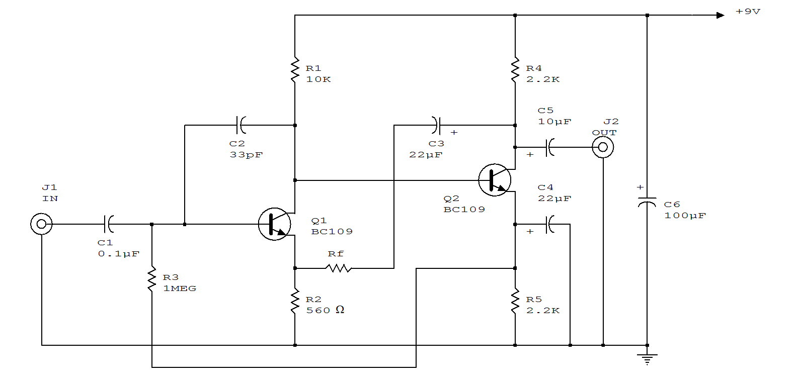
LOW-IMPEDANCE MICROPHONE PREAMP

This amplifier uses a common-gate FET amplifier to match a low-Z microphone.
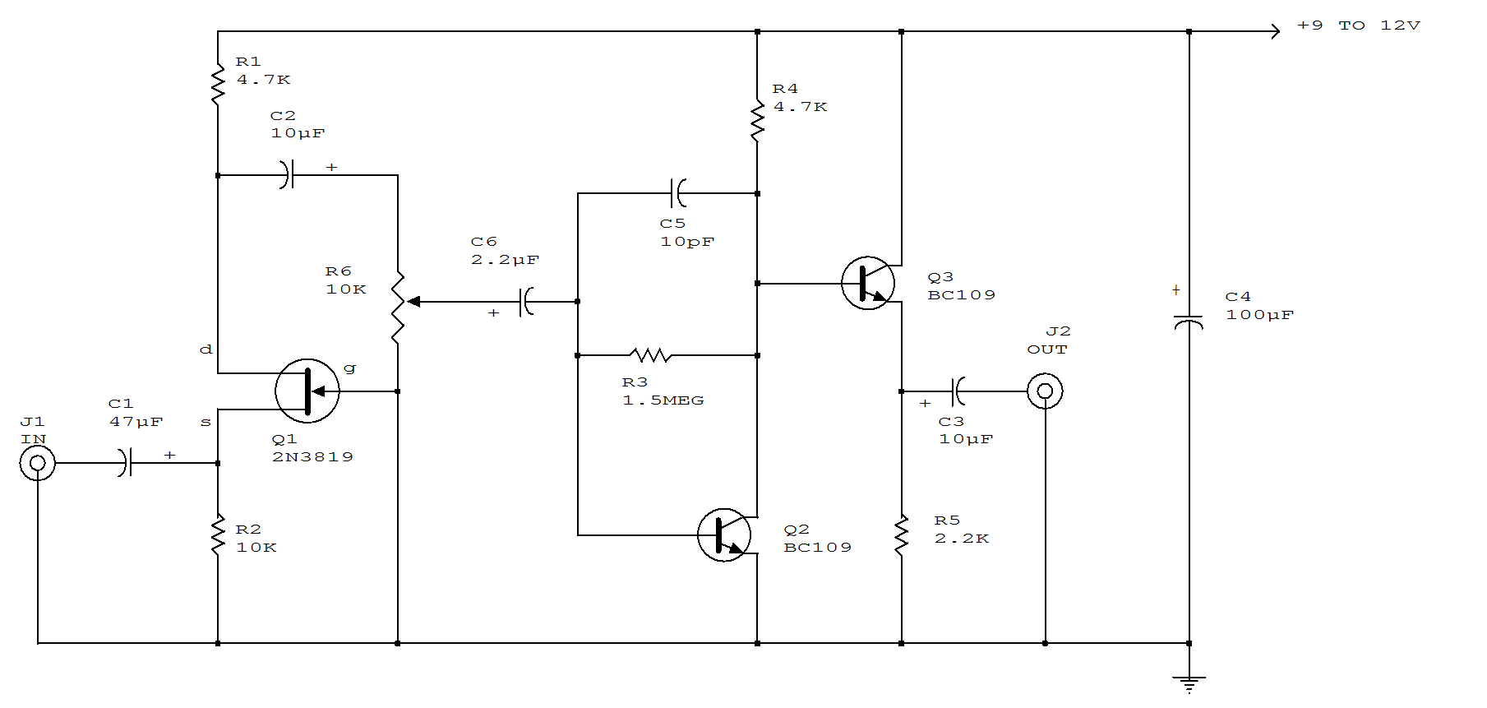
AUDIO OSCILLATOR

Almost any transistor will work. R1 and C1 will vary the tone.
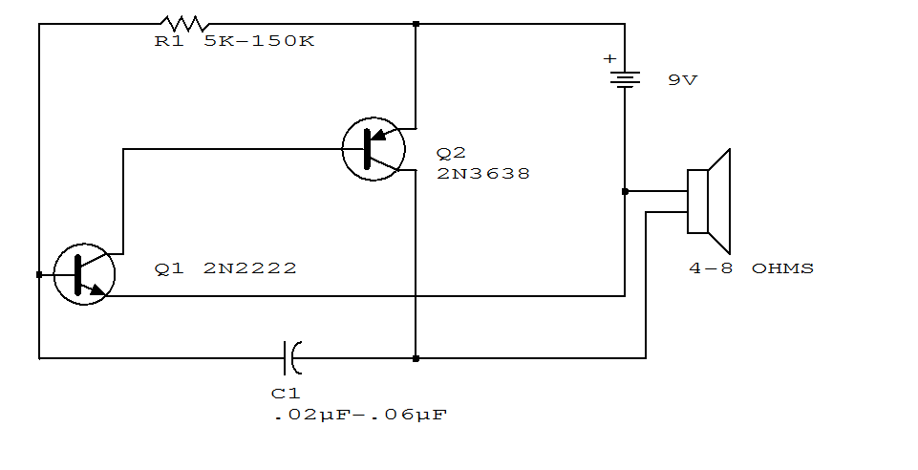

PHASE-SHIFT OSCILLATOR

This circuit uses a simple RC network to produce an exceptionally shrill tone from a miniature speaker. With the parts values shown, the circuit oscillates at a frequency of 3.6 kHz and drives a miniature 2-1/2" speaker with ear-piercing volume.
The output waveform is a square wave with a width of 150 us, sloping rise and fall times, and a peak-to-peak amplitude of 4.2 volts (when powered by 9 volts). Current drain of the oscillator is 90 mA at 9 volts, and total power dissipation at this voltage is 0.81 watt, which is well below the 1.25 watts the 14-pin version will absorb (at room temperature) before shutting down.
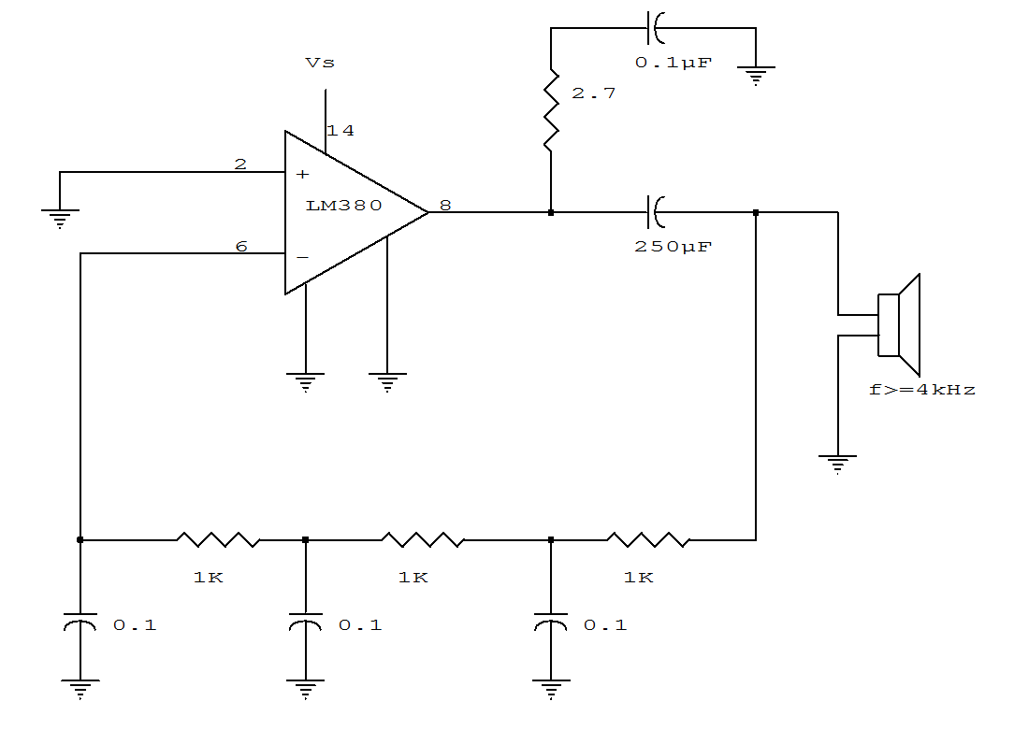
AUTO GENERATOR REGULATOR

This regulator controls a dc generator. D4 prevents the battery from discharging through the generator and takes the place of the mechanical cut-out relay. R10 adjusts the system voltage setting.

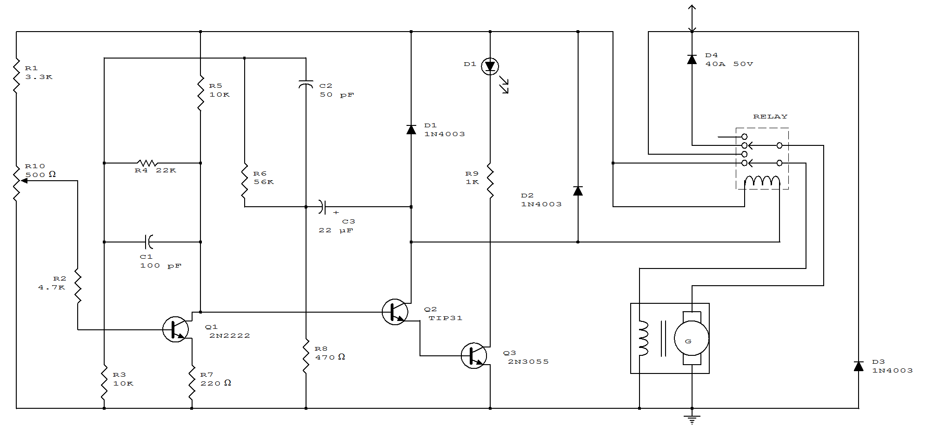

AUTO TURN-OFF ALARM WITH 8 MINUTE DELAY

This circuit uses a NE555 timer and CD4020B. When +12Vdc is applied to the circuit, the output of IC2 is set low via C2, which turns on the relay, and IC1, a pulse generator. IC1 pulses counter IC2. After 8192 clocks, IC2 output (pin 3) goes high, cuts off Q2, and completes the cycle.
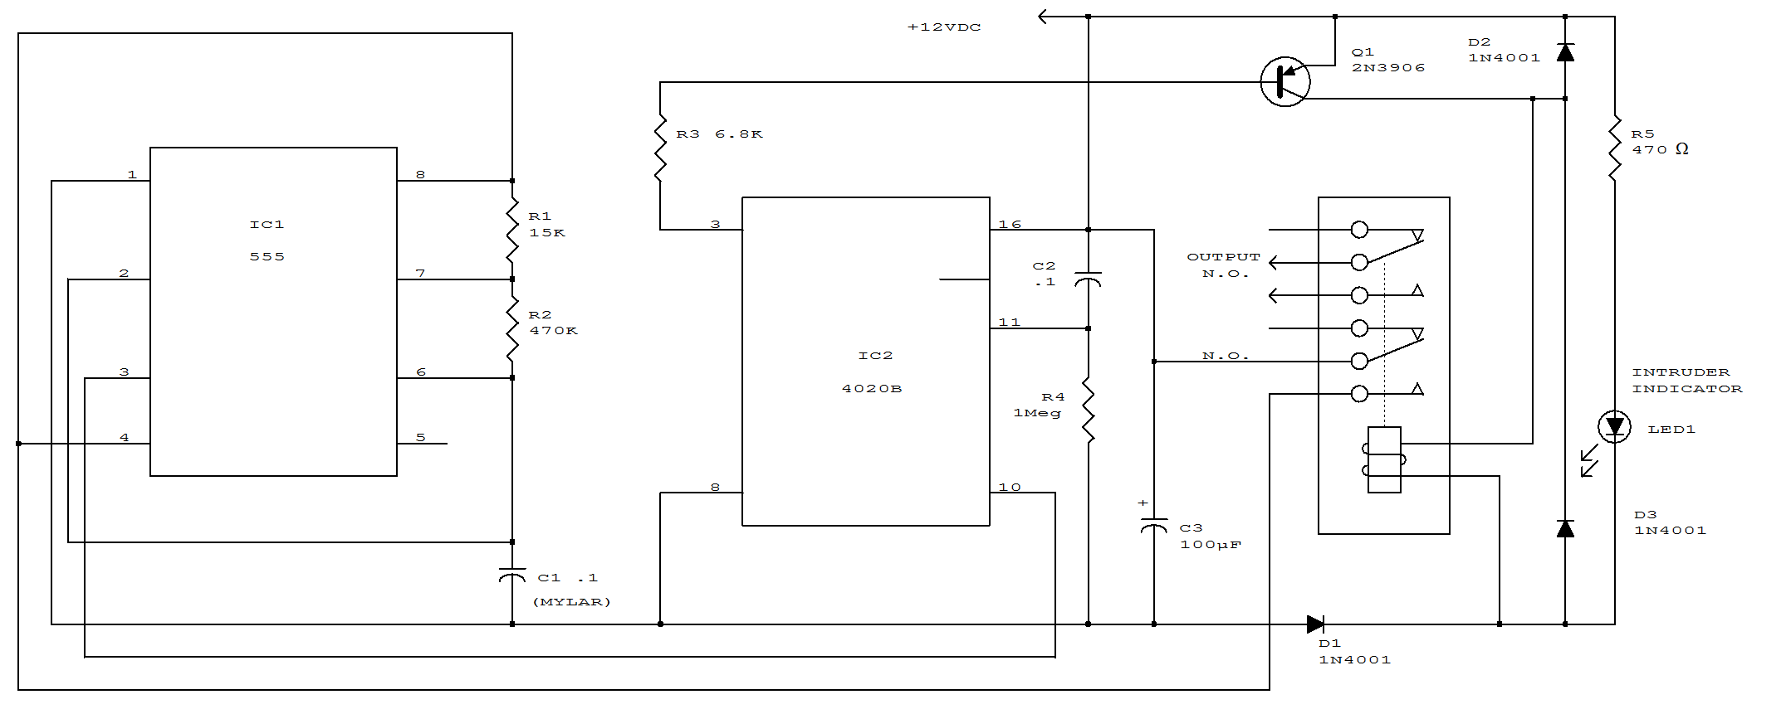

AUTOMATIC HEADLIGHT DELAY

When the driver depresses pushbutton switch S1, timing capacitor C1 charges to 12 V and turns on transistor Q1, which drives power transistor Q2 into conduction. This, in turn, energizes the relay which has its contacts connected in parallel with the headlight switch. The relay will stay energized until C1 discharges to the Q1 turn-off level. The lights-on period is determined by the value of C1, R1, and the characteristics of transistor Q1. With values chosen on the schematic, about 60 light-on seconds are provided.
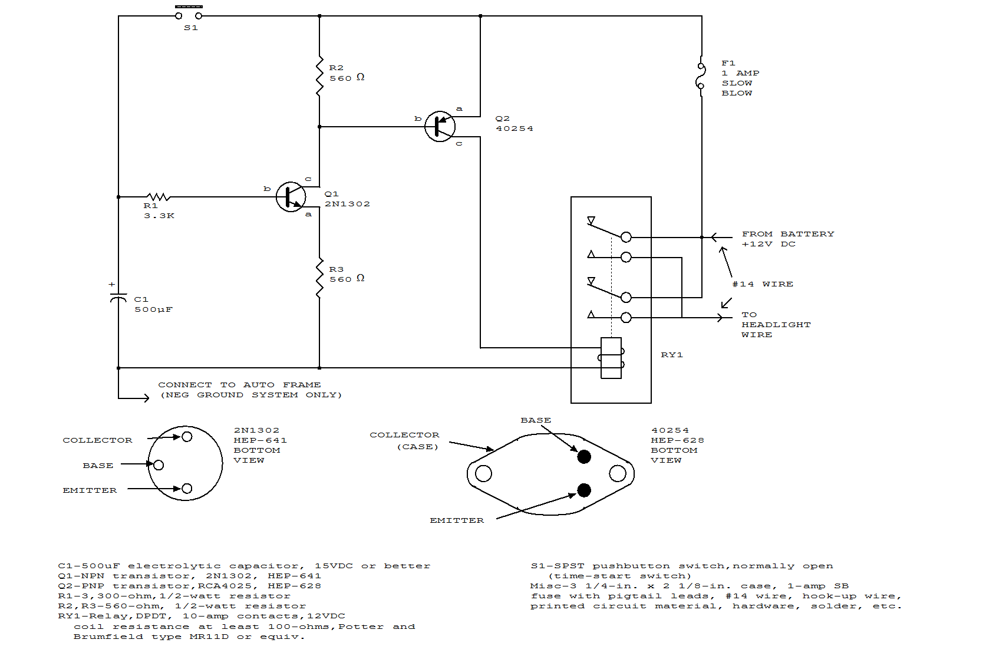
AUTOMATIC TURN-OFF ALARM WITH DELAY
In this circuit, IC1A and IC1B act as a monostable multivibrator. Any input from the sensors S1 through S5 forces IC1A to produce logic low, which causes IC1B to turn on Q1 until C3 changes through R6. This action resets the latch formed by IC1A and IC1B.
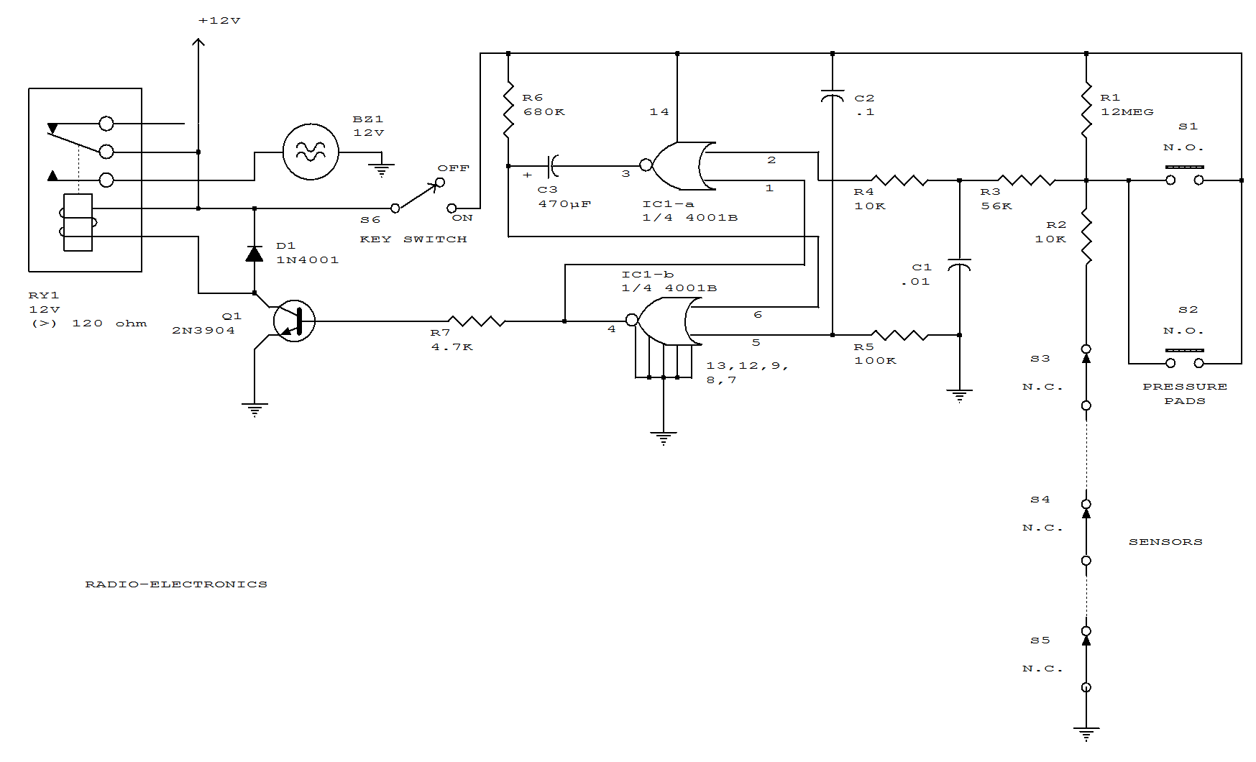
AUTOMOBILE LOCATOR
This locator is made up of two parts. The first is an RF oscillator, whose circuit is shown in Fig. 8-4a. The second is a sensitive receiver shown in Fig. 8-4b. The heart of the oscillator is a 555 timer IC. Tank circuit C2 and L1 is used to tune the transmitter. The antenna is coupled to the transmitter through C3. A telescopic antenna or a length of hookup wire will work quite well. At the receiver, the incoming signal is tuned by C5 and L2 before being passed on to the 741 IC.
The five LEDs are used to indicated signal strength, they light up in order (1 to 5) as the signal gets stronger.
After the devices are built, the receiver and transmitter will need to be tuned. Tune the transmitter until all of the receiver's LEDs light. Separate the receiver and the transmitter--the farther apart they are the better--and adjust R4 until you get a maximum strength reading only when the receiver's antenna is pointed directly at the transmitter. Place the transmitter on the dashboard and completely extend the antenna. To find your car, just extend the telescope antenna to its full length and hold it parallel to the ground. Point the antenna to your far left, then swing it to your far right. Do that until you find in which direction the strongest signal lies, as indicated by the LEDs. The antenna will be pointing at your car.
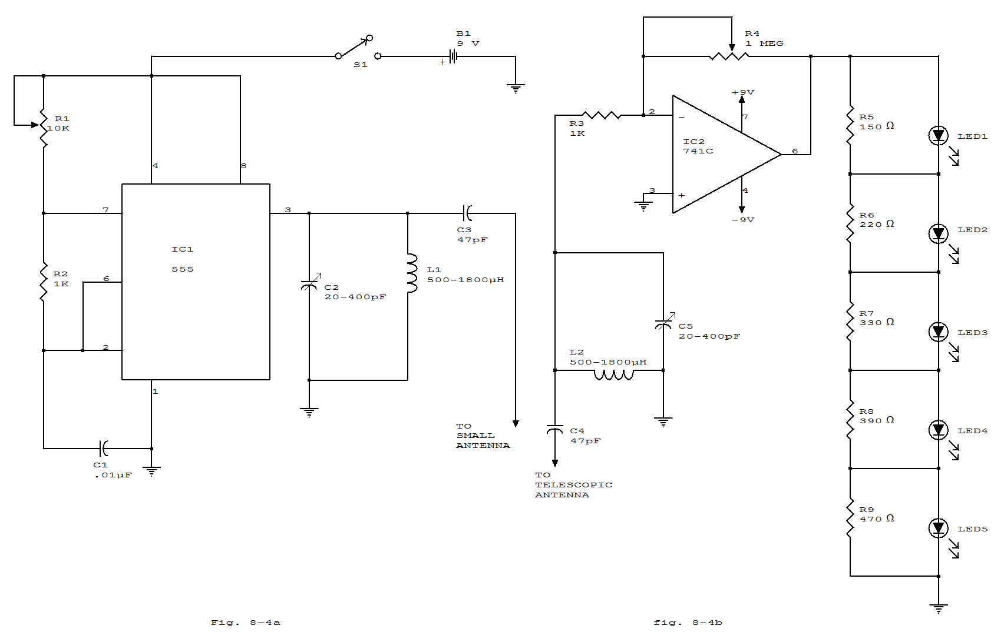

BAR-GRAPH VOLTMETER
This display uses ten LED's to display a voltage range from 10.5 to 15 volts. Each LED represents a 0.5-volts step in voltage. The heart of the circuit is the LM-3914 dot/bar display driver. trimmer potentiometer R5 is adjusted so that 7.5 volts is applied to the top side of the divider. Resistor R7 and diodes D2 through D5 clamp the voltage applied to the LED's to about 3 volts. A lowpass filter made up of L1 and C2 guards against voltage spikes. Diode D1 is used to protect against reverse voltage in case the voltmeter is hooked up backward.
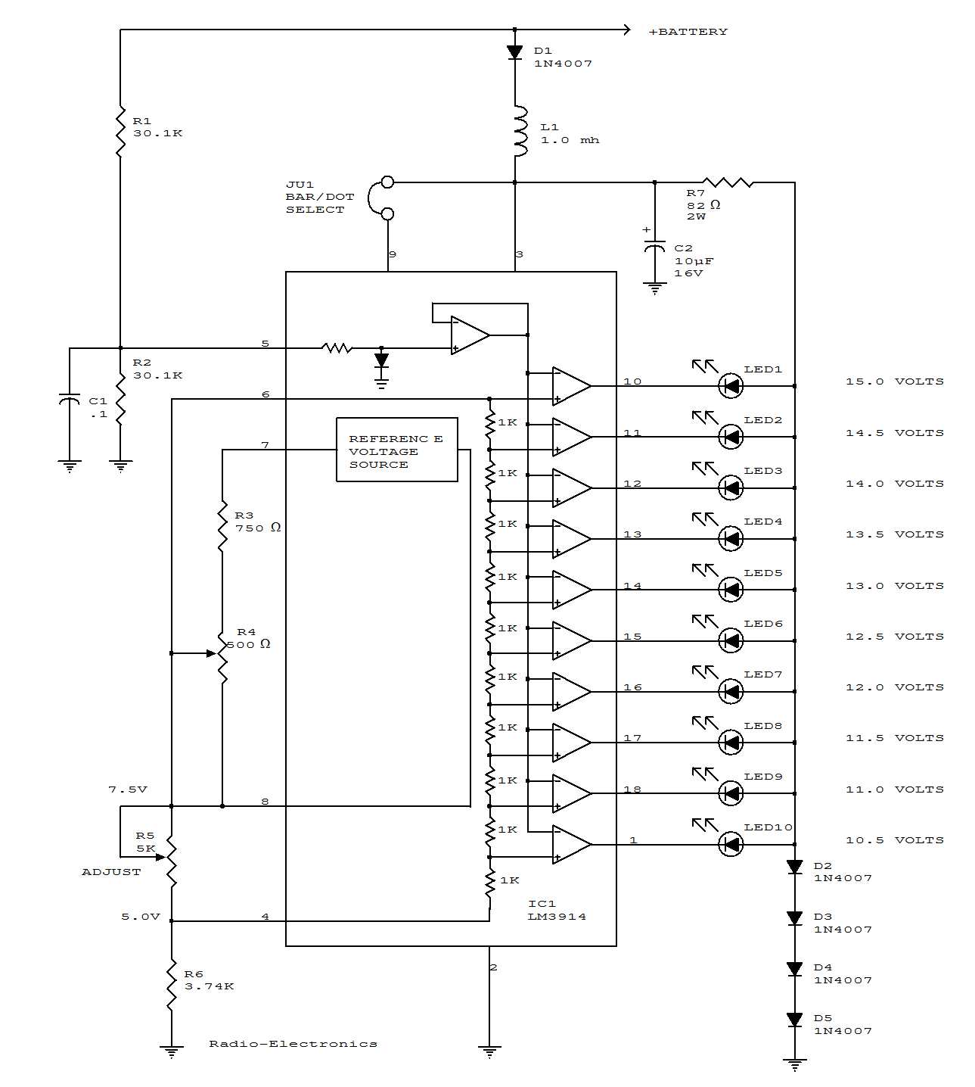
DIRECTIONAL SIGNALS MONITOR
A unijunction transistor audio oscillator drives a small speaker. The oscillator's frequency is determined by resistor R2 and capacitor C2. The operating voltage is supplied from the car's turn-signal circuit(s) through D1 and D2. The diodes conduct current from the blinker circuit that is energized, and prevent stray current flow to the other blinker circuit.

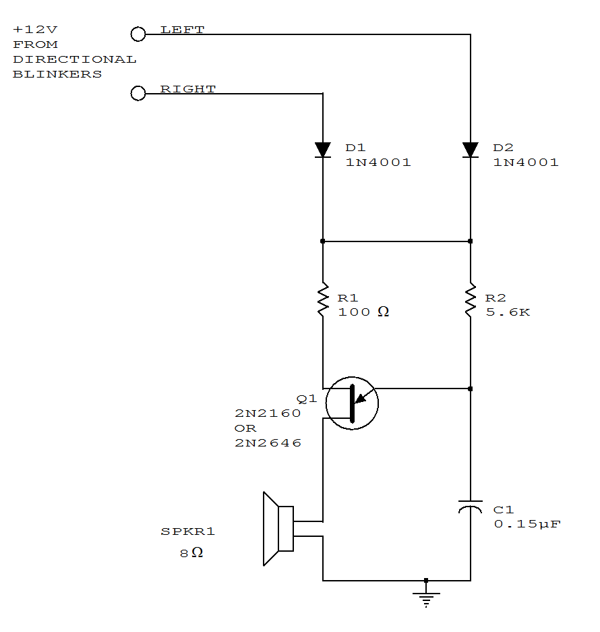
ELECTRONIC CAR HORN
An LM556 dual oscillator/timer, U1, configured as a two-tone oscillator drives U2, a dual 4-watt amplifier. One of the oscillators, pins 1 to 6, contained in U1 produces the upper frequency signal of about 200 Hz, while the second oscillator, pins 8 to 13, provides the lower frequency signal of about 140Hz. Increase or decrease the frequencies by changing the values of C2 and C3. U1's outputs, pins 9 and 5, are connected to separate potentiometers to provide control over volume and balance. Each half of U2 produces 4W of audio that is delivered to two 8 ohms loudspeakers via capacitors C7 and C8.
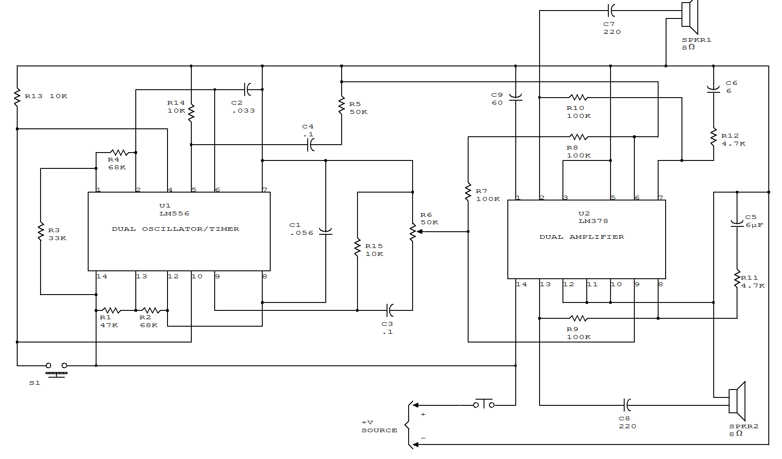
HEADLIGHT ALARM
The base of Q1 is connected to the car's ignition circuit. One side of the piezoelectric buzzer is connected to the instrument-panel light fuse. When the headlights are off, no current reaches the buzzer, and therefore nothing happens.
What happens when the headlights are on depends on the state of the ignition switch. When the ignition switch is on, transistors Q1 and Q2 are biased on, removing the buzzer and the LED from the circuit. When the ignition switch is turned off, but the headlight switch remains on; transistor Q1 is turned off, but transistor Q2 continues to be biased on. The result is that the voltage is sufficient to sound the buzzer loudly and light the LED. Turning off the headlight switch will end commotion quickly.
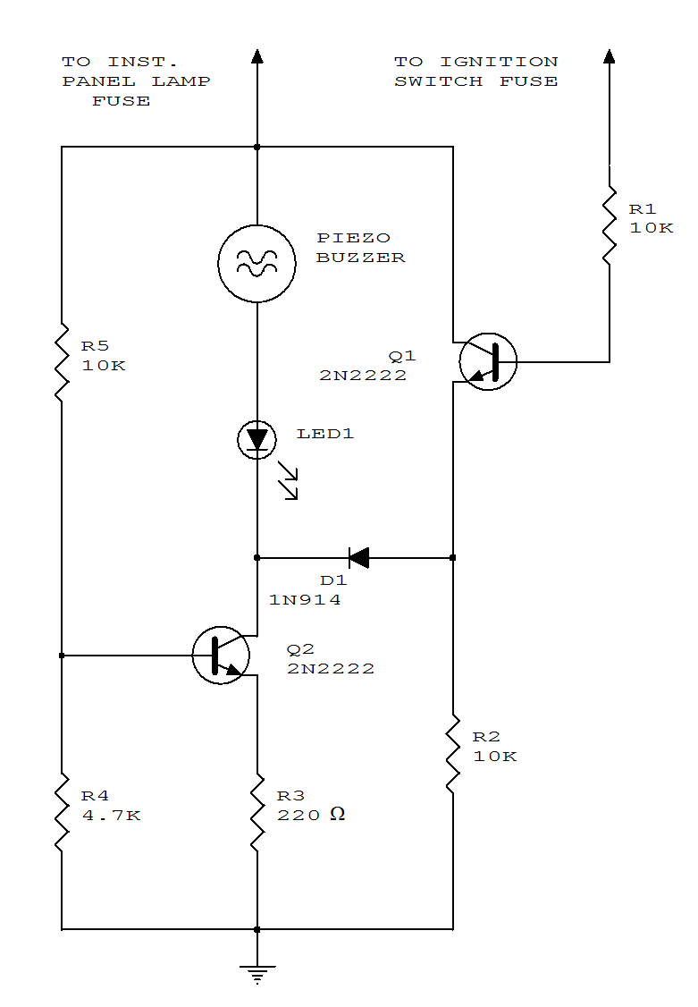
FLASHING BRAKE LIGHT
When power is first applied, three things happen: the light-driving transistor (Q1) is switched on because of a low output from U2, pin 3; timer U1 begins its timing cycle, with the output (pin 3) going high, inhibiting U2's trigger (pin 2) via D2; and charge current begins to move through R3 and R4 to C1.
When U1's output goes low, the inhibiting bias on U2 pin 2 is removed, so U2 begins to oscillate, flashing the third light via Q1, at a rate determined by R8, R6, and C3. Oscillation continues until the gate-threshold voltage of SCR1 is reached, causing it to fire and pull U1's trigger (pin 2) low. With its trigger low, U1's output is forced high, disabling U2's triggering. With triggering inhibited, U2's output switches to a low state, which makes Q1 conduct, turning on I1 until the brakes are released. Removing power from the circuits resets SCR1, but the RC network consisting of R4 and C1 will not discharge immediately and will trigger SCR1 earlier. So, frequent brake use means fewer flashes.
Bear in mind that the collector/emitter voltage drop across Q1, along with the loss across the series-fed diodes, reduces the maximum available light output. If the electrical system is functioning properly (at 13 to 14 V for most vehicles), those losses will be negligible.

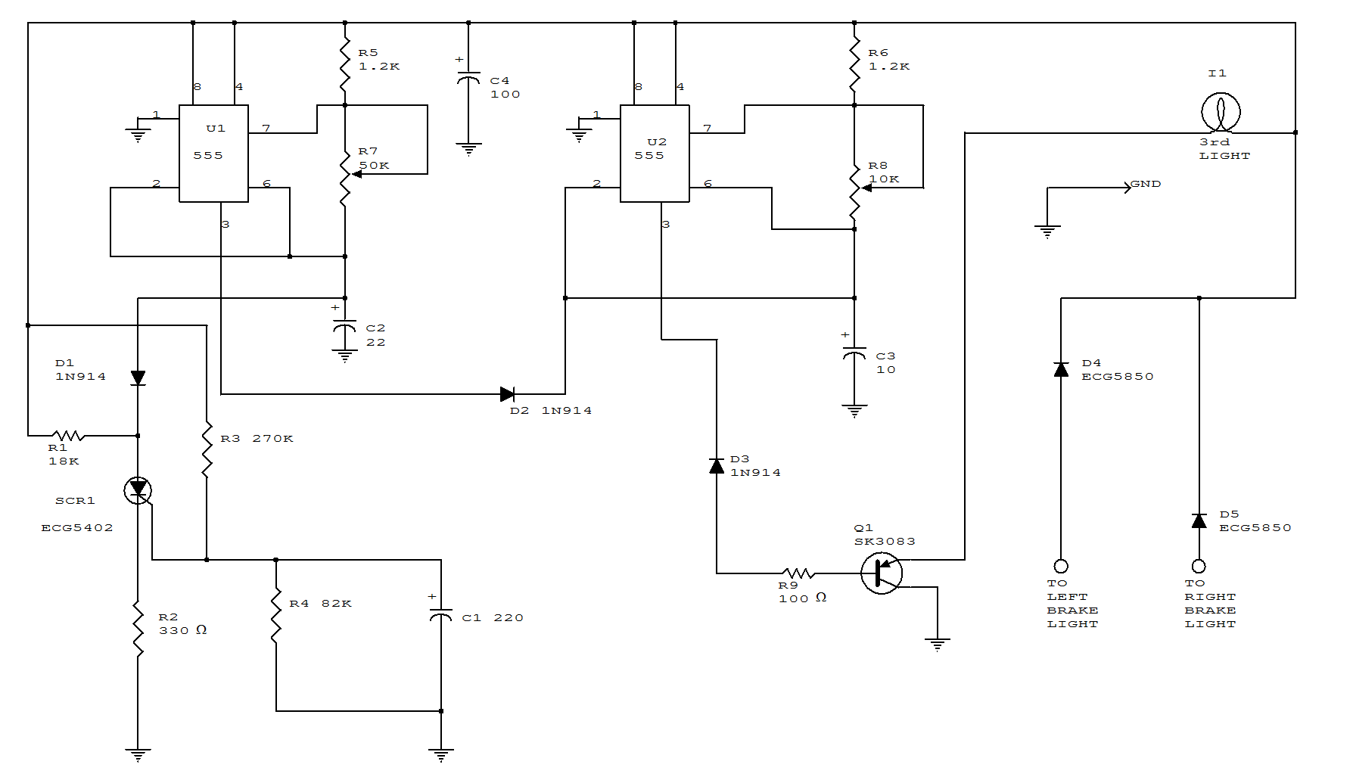

HEADLIGHT DIMMER

When the lights of an on-coming car are sensed by photo-transistor Q1, things get going. Sensitivity is set by the 22-megohm resistor, R5, to about half a foot-candle. The relay used has a 12-volt, 0.3A coil. The L14C1is complete with a lens that has a diameter of one inch for a 10 degree viewing angle.
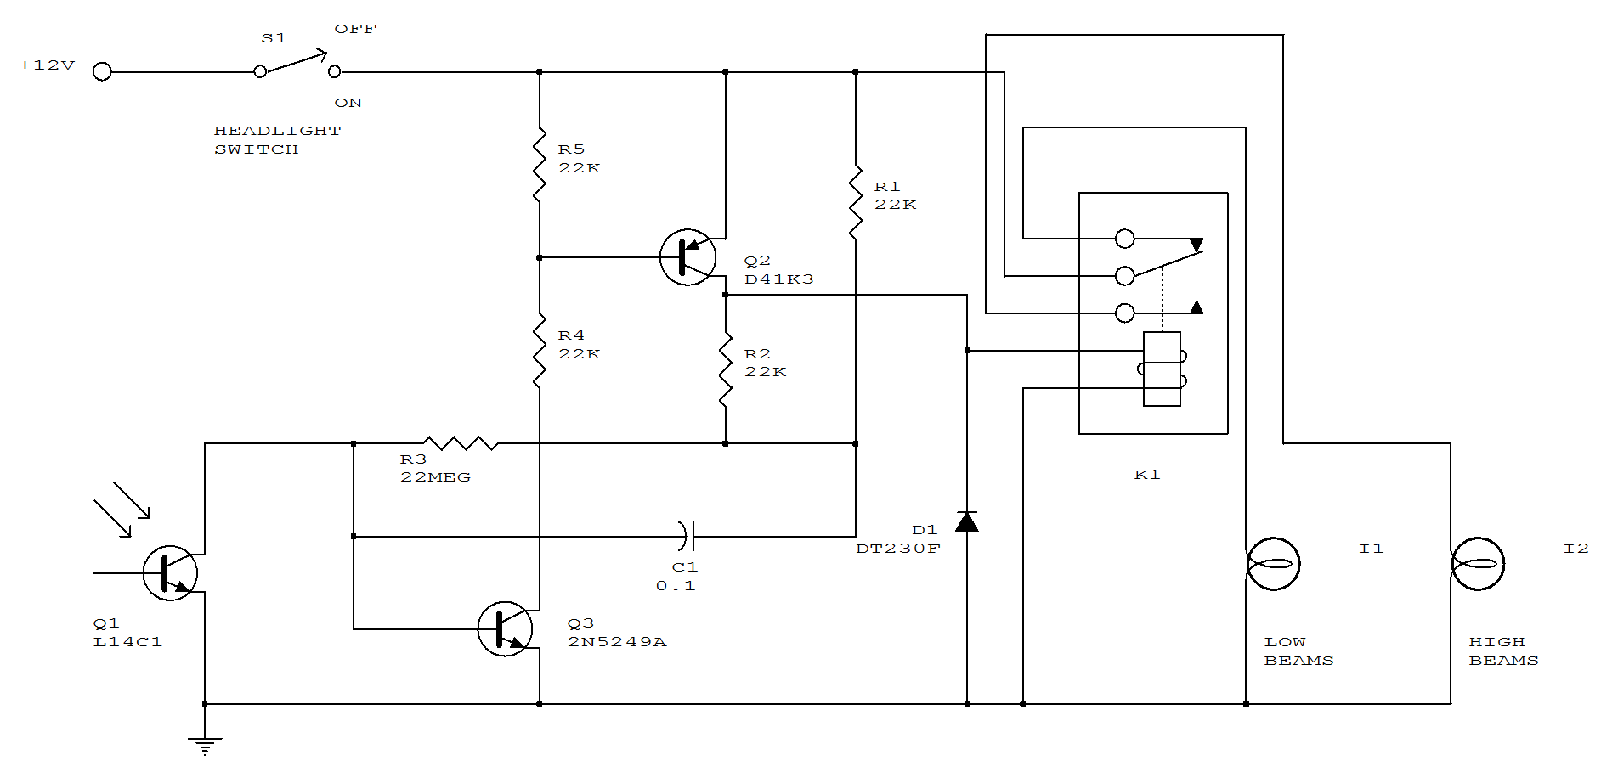
OVER-SPEED WARNING DEVICE

A1 amplifies and regulates the signal from the spark coil. A2 converts frequency to voltage so that its output is a voltage proportional to engine rpm. A3 compares the tachometer voltage with the reference voltage and turns on the output transistor at the set speed. Amplifier A4 is used to generate an audible tone whenever the set speed is exceeded.
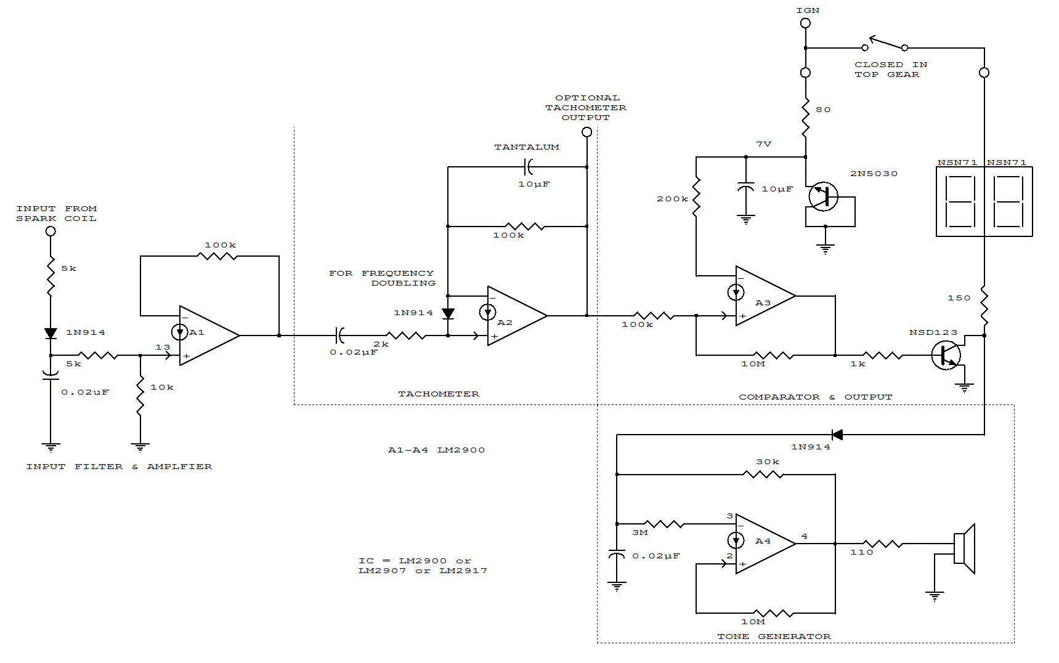

IGNITION TIMING LIGHT
Figure A shows the circuit of a direct-trigger timing light. The trigger voltage is taken from the car's ignition circuit by a direct connection to a spark plug. A circuit using an inductive pickup is shown in Fig. B. A trigger transformer is used to develop the high-voltage pulse for triggering. The triggering circuit consists of T1, C1, SCR1, inductive pickup coil T2, and the waveshaping components of SCR's gate circuit.
When the spark plug fires, it induces a pulse in pickup coil T2 that triggers the SCR gate. The SCR fires and discharges C2 through the primary of T1. The secondary of T1 feeds a high-voltage pulse to the trigger electrode of the flash tube. That pulse causes the gas--usually neon or xenon-to ionize. The ionized gas provides a low-resistance path for C1 to discharge, thereby creating a brilliant flash of light.
Resistor R1 limits current from the supply as the tube fires. When C1 is fully discharged the strobe tube cuts off and returns to its "high-resistance" state. The current through R2 is not enough to sustain conduction through SCR1, so it cuts off and remains off until it is re-triggered by a gate pulse.
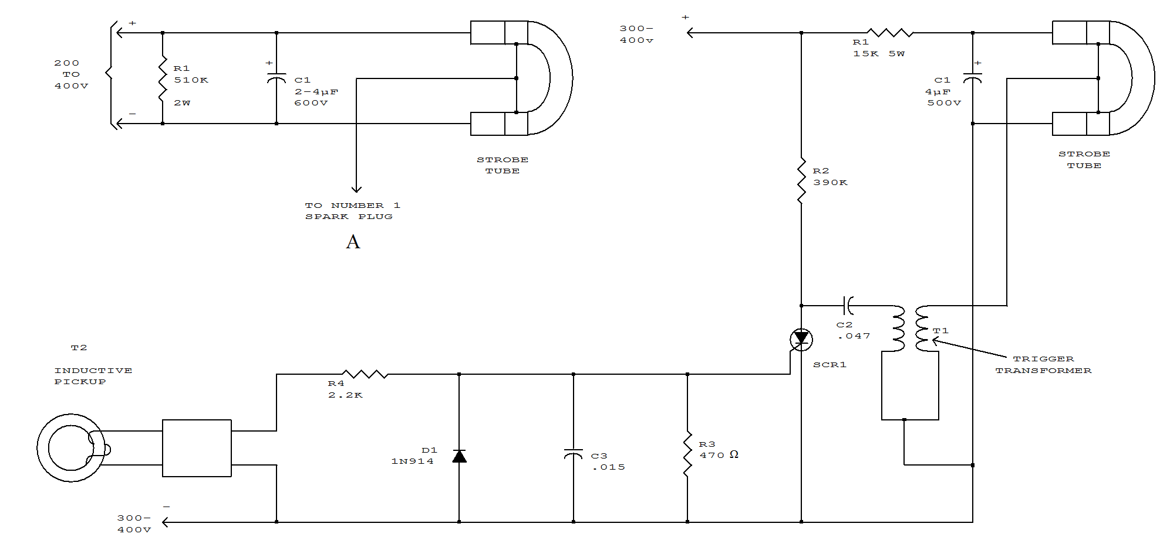
LIGHTS-ON WARNING

Because power for the circuit is obtained from the car's side lights, the circuit can't oscillate unless the lights are on. The reset pin on the 555 connects to transistor Q1. The base of Q1 is connected through R1 to the ignition auxiliary terminal on the car's fuse box. When the ignition is turned on, power is supplied to the base of Q1, which turns it on. With Q1 turned on, pin 4 of U1 is tied low, which disables the oscillator and inhibits the alarm. If the ignition is turned off while the lights are on, power is applied to the 555 and Q1 is turned off, and the alarm starts. Switch S1 is an optional override. 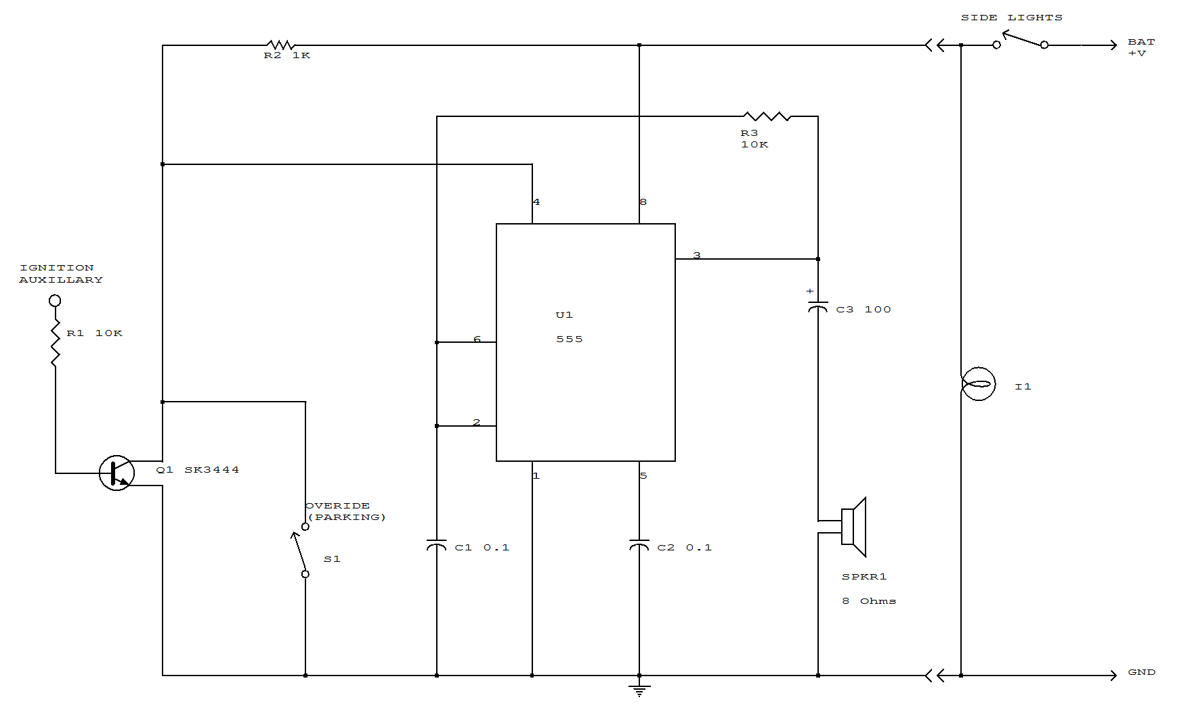

NIGHT SAFETY LIGHT FOR AUTOS
This circuit turns on the brake lights of a parked car when the headlights of an oncoming car are detected, warning the driver of the oncoming car about the parked vehicle. LDR4 is the sensor. LDR1 disables the circuit by causing U1 gate input to be pulled high during daylight hours, causing pin 2 of U1a to become low, disabling it and the circuit.
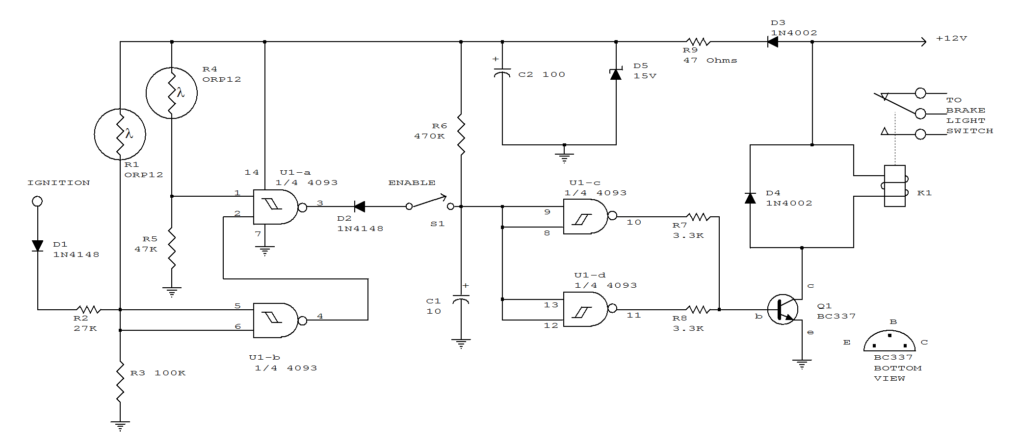

TACHOMETER
In this automotive application, the 555 is a pulse counter. IC1 regulator provides proper operating voltage for IC2. This circuit is for vehicles with conventional breaker points.
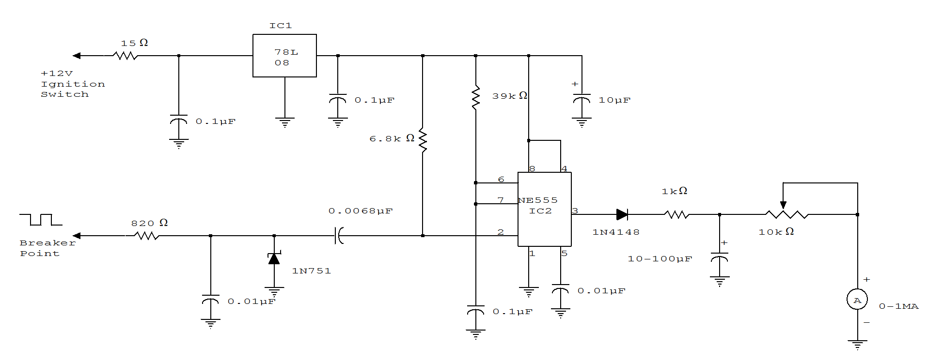
VOLTAGE REGULATOR FOR CARS AND MOTORCYCLES
This regular circuit can be used on an alternator that has one field terminal grounded. When +V (input) gets too high, Q1 conducts, and the base of Q2 is driven toward ground, reducing the voltage fed to Q3. This lowers the voltage fed to the field of the alternator.
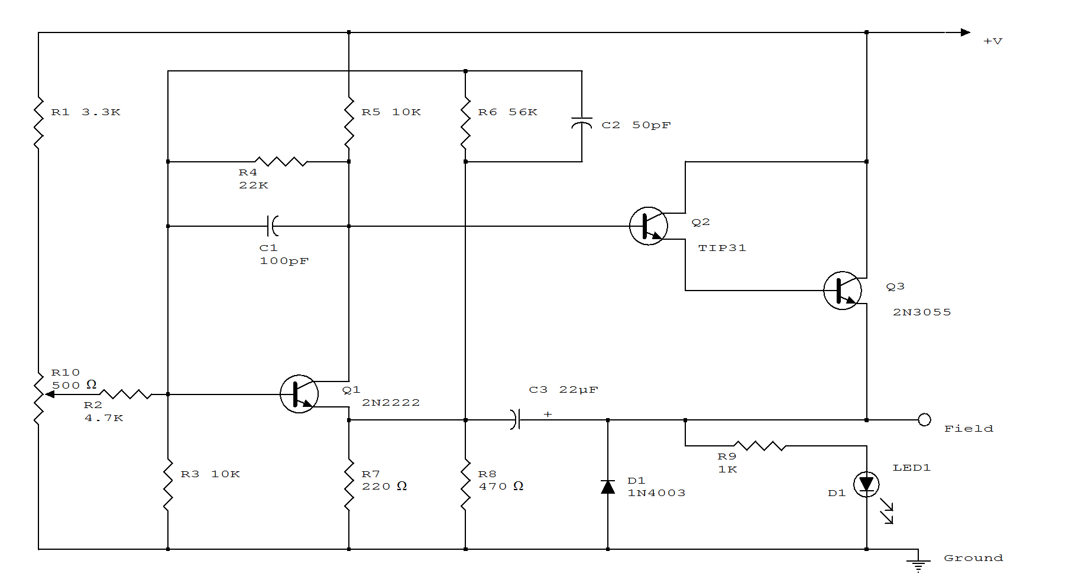
WINDSHIELD WIPER CONTROL
Here's a good way to set windshield wipers on an interval circuit. Only two connections to the car's wiper control, plus ground, are required. Variable control can be accomplished by substituting a 500k pot in series with a 100k fixed resistor in place of the 560k.
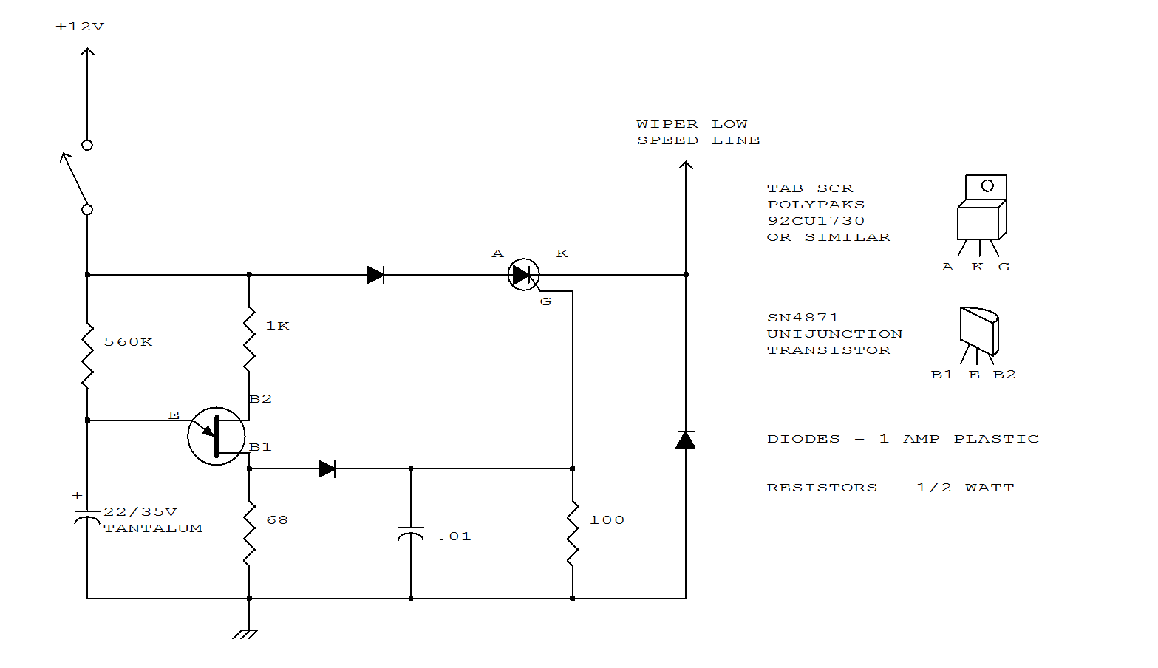
BATTERY VOLTAGE MONITOR

This circuit gives an early warning of the discharge of batteries. Zener diode D1 is chosen for the voltage below which an indication is required (9V). Should the supply drop to below 7V, D1 will cease conducting causing Q1 to shut off.
Its collector voltage will now increase causing Q2 to start conducting via LED and its limiting resistor R4.
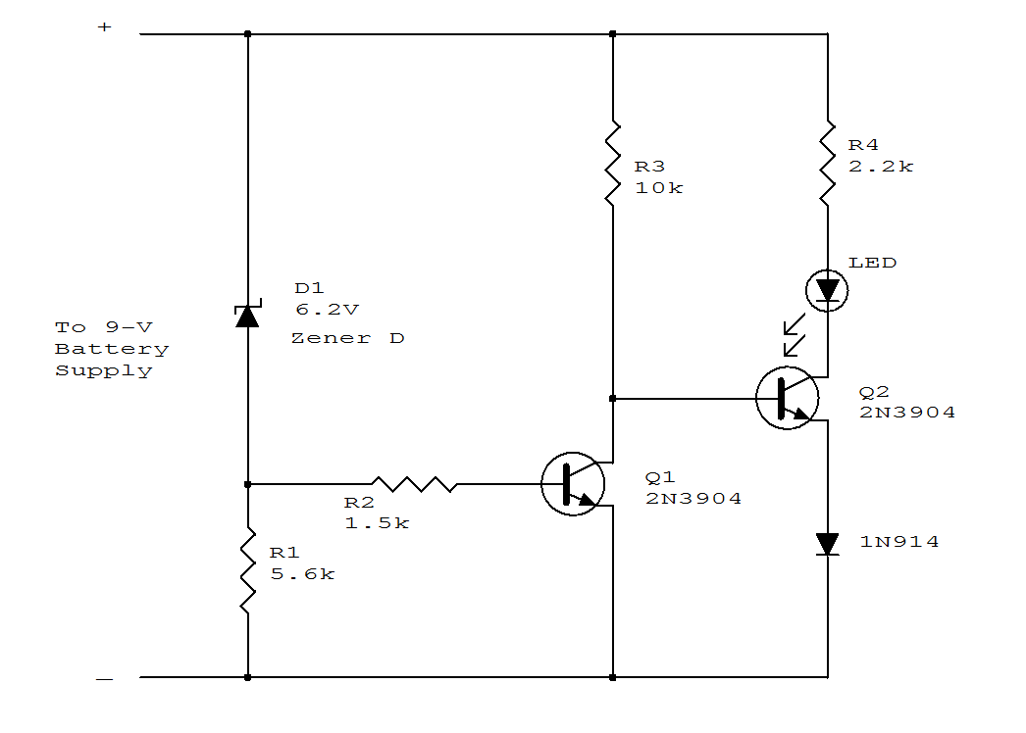
INDUCTANCE BRIDGE

This bridge will measure inductances from about 1 to 30 uH at a test frequency of 5 mHz. A 365-pF AM-type tuning capacitor is used as a variable element. The circuit should be constructed in a metal enclosure. Calibration can be done on known inductors or by plotting a curve of the capacitance of the 365-pF capacitor versus rotation and calculating the inductance from this. The range of measurement can be changed by using a different frequency crystal and/or variation of L2 and C6.
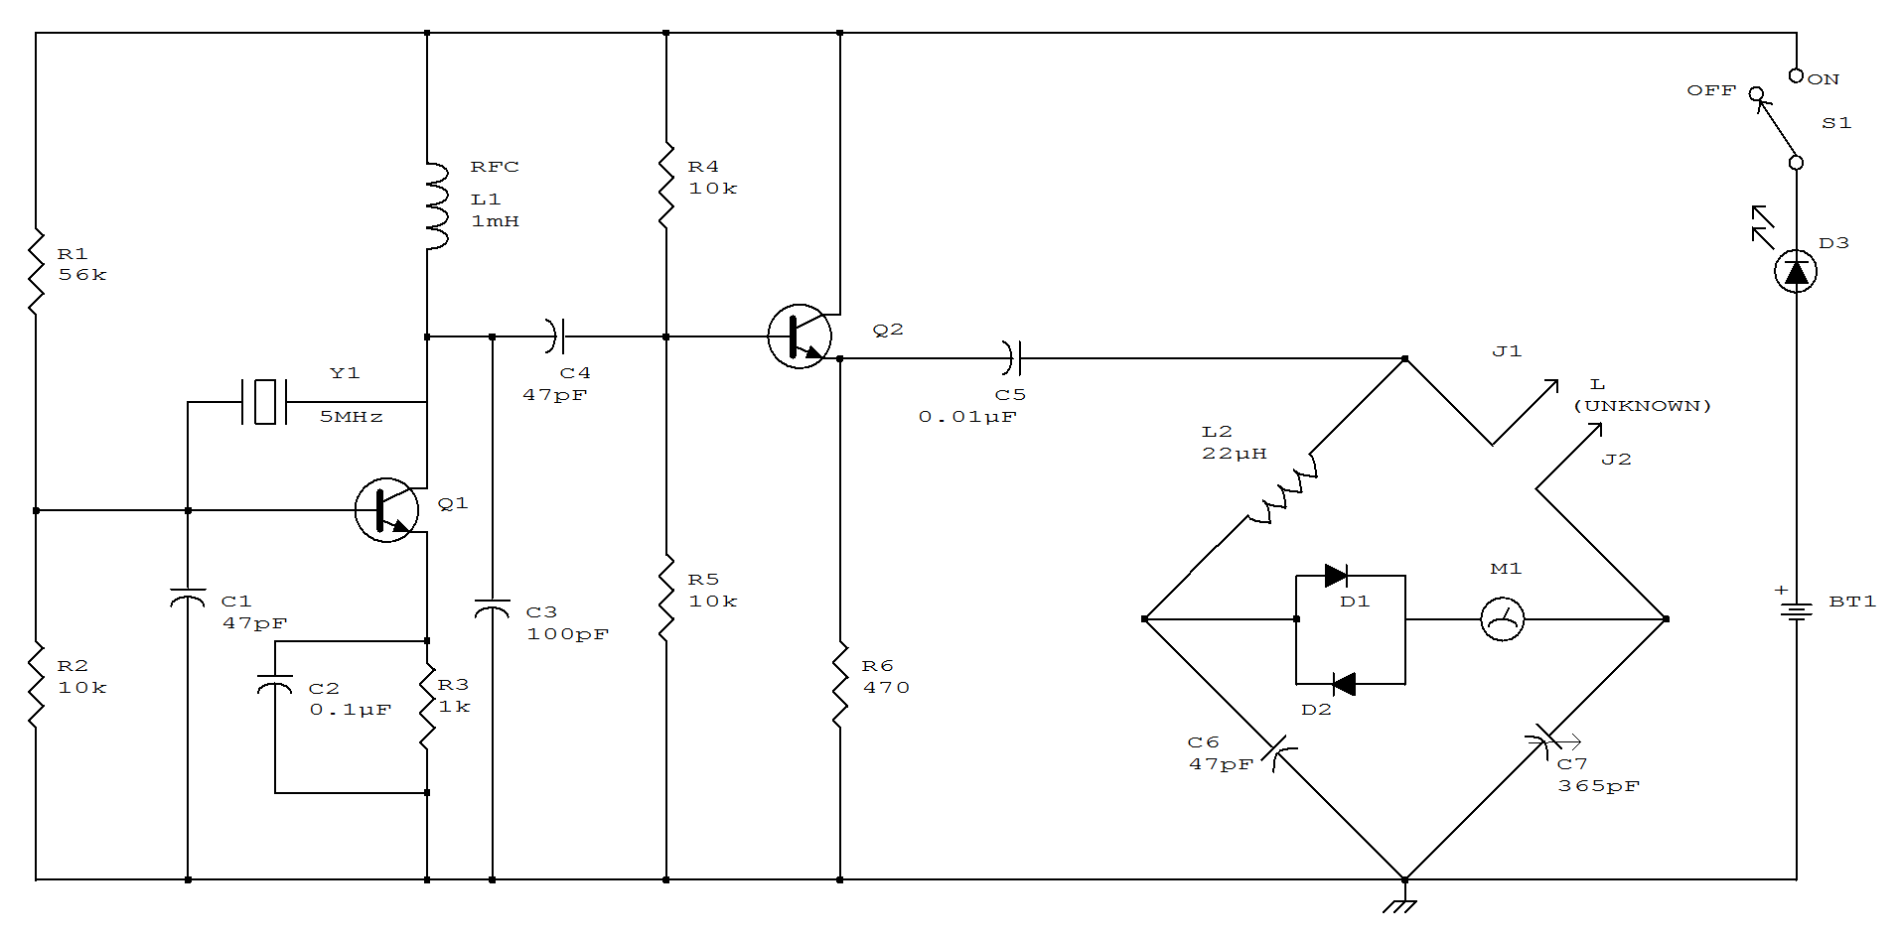
HIGH IMPEDANCE LOW CAPACITANCE WIDEBAND BUFFER
The 2N5485 has low input capacitance and makes this compound series-feedback buffer a wide-band unity gain amplifier.
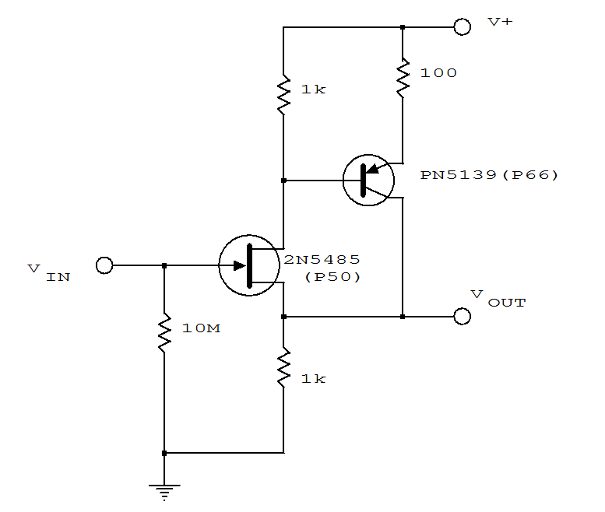

SINGLE SUPPLY AC BUFFER AMPLIFIER

The input is dc biased to mid-operating point and is ac coupled. Its input impedance is approximately 500K at low frequencies. For dc loads referenced to ground, the quiescent current is increased by the load current set at the input dc bias voltage.
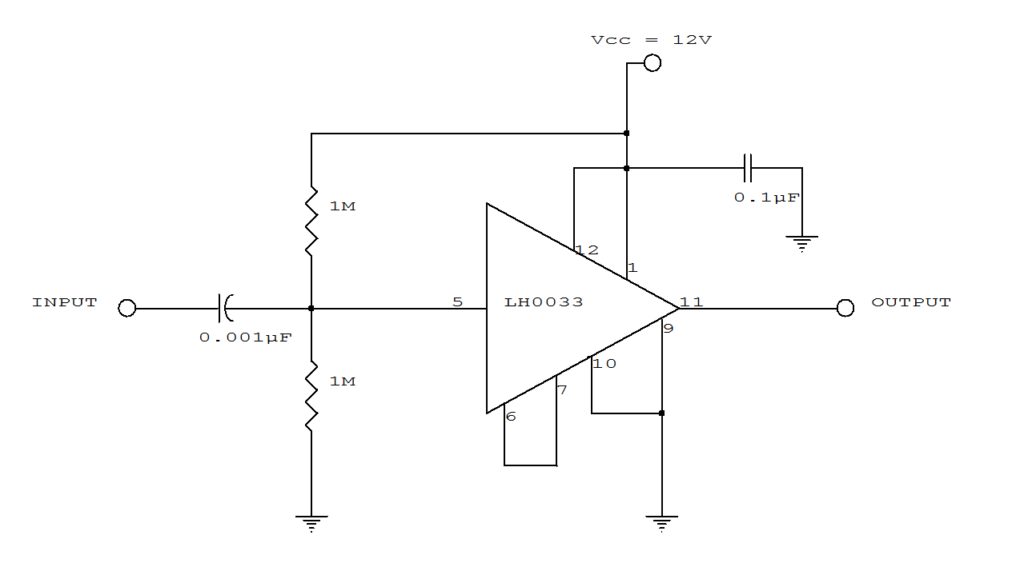
VFO BUFFER AMPLIFIER

A two-transistor feedback pair provides broadband operation. The gain is approximately R4/R1.
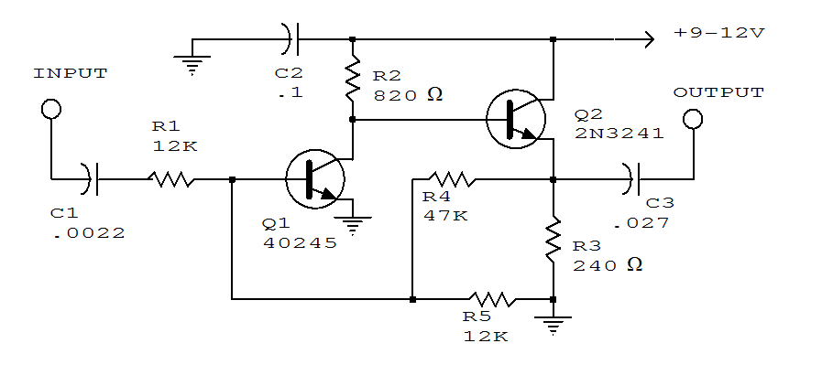
SINGLE-TIMER IC PROVIDES SQUARE-WAVE TONE BURSTS

The tone-burst generator gives a 50-ms burst of 1.5 kHz square waves with each operation of the pushbutton and can source or sink 200 mA.
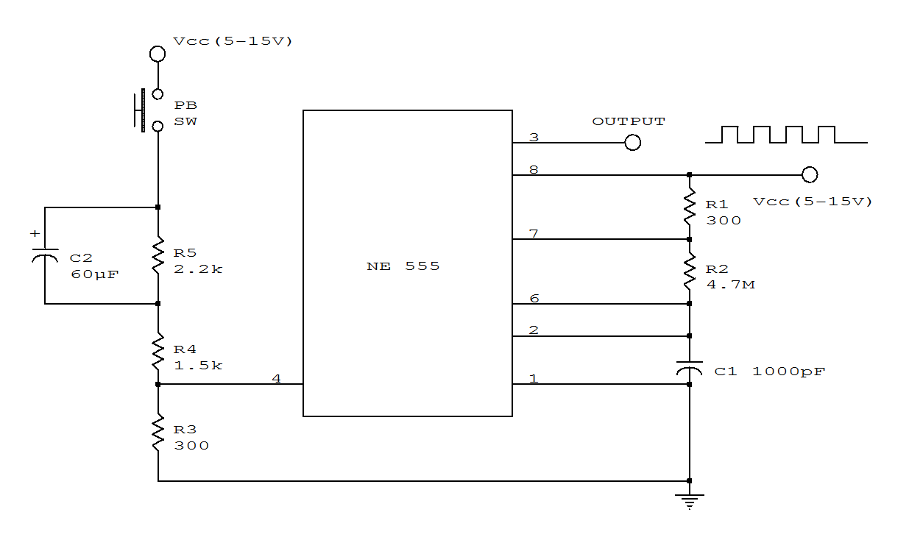

SINGLE-TONE BURST GENERATOR

The tone burst generator supplies a tone for one-half second after the power supply is activated; its intended use is a communications network alert signal. Cessation of the tone is accomplished at the SCR, which shunts the timing capacitor C1 charge current when activated. The SCR is gated on when C2 charges up to the voltage which occurs in 0.5 seconds. Since only 70 uA are available for triggering, the SCR must be sensitive enough to trigger at this level. The triggering current can be increased, of course, by reducing R2 (and increasing C2 to keep the same time constant). If the tone duration must be constant under widely varying supply voltage conditions, the optional Zener diode regulator circuit can be added, along with the new value for R2R2' = 82 kohms. If the SCR is replaced by an npn transistor, the tone can be switched on and off at will at the transistor base terminal.

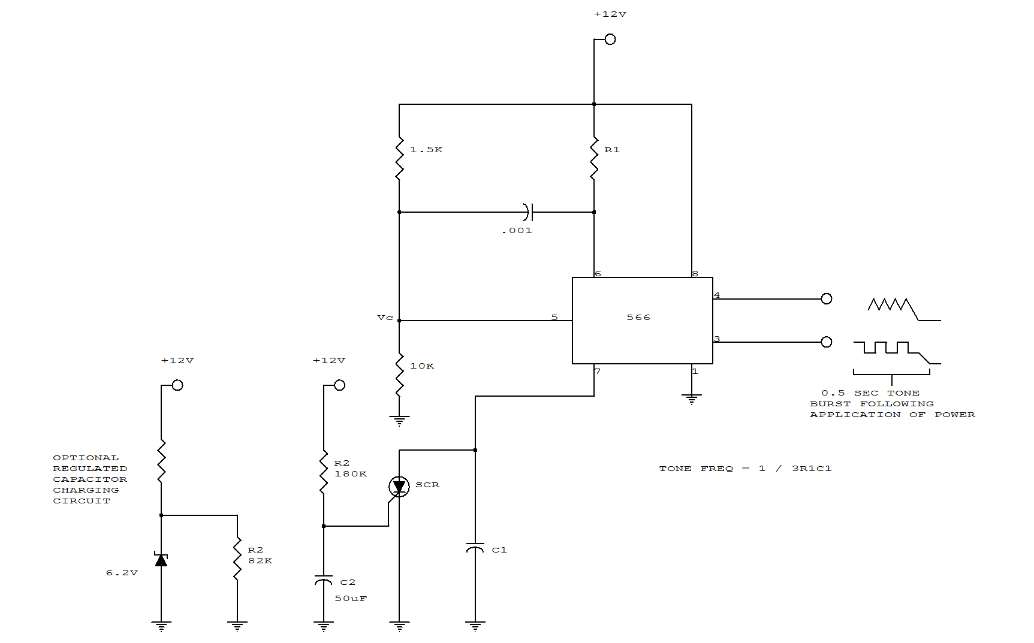

PROXIMITY ALARM

Inverters U1a and U1b are connected in a simple RC oscillator circuit. The frequency is determined by the values of R1, C1 C2 and the internal characteristics of the integrated circuit. As long as the circuit is oscillating, a positive dc voltage is developed at the output of the voltage-couple circuit: C3, D2 and C4. The dc voltage is applied to the input of U1c-the third inverter amplifier-keeping its output in a low state, which keeps Q1 turned off so that no sound is produced by BZ1. With C1 and C2 adjusted to the most sensitive point, the pickup plate will detect a hand 3 to 5-inches away and sound an alert. Set C1 and C2 to approximately one-half of their maximum value and apply power to the circuit. The circuit should oscillate and no sound should be heard. Using a non-metallic screwdriver, carefully adjust C1 and C2, one at a time, to a lower value until the circuit just ceases oscillation: Buzzer BZ1 should sound off. Back off either C1 or C2 just a smidgen until the oscillator starts up again-that is the most sensitive setting of the circuit.
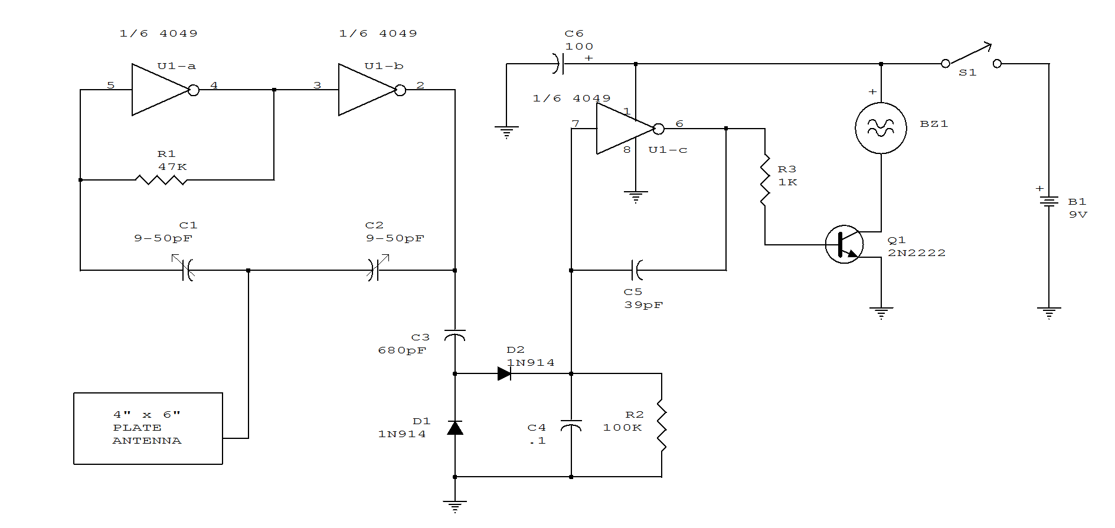

PROXIMITY SWITCH

A 3x3 inch piece of circuit board, or similar size metal object which functions as the pick-up sensor, is connected to the gate of Q1. A 100 meg resistor, R2, isolates Q1's gate from R1, allowing the input impedance to remain very high. If a 100 meg resistor cannot be located, just tie five 22 meg resistors in series and use that combination for R2. In fact, R2 can be made even higher in value for added sensitivity. Potentiometer R1 is adjusted to where the piezo buzzer just begins to sound off and then carefully backs off to where the sound ceases. Experimenting with the setting of R1 will help in obtaining the best sensitivity adjustment for the circuit. Resistor R1 can be set to where the pick-up must be contacted to set off the alarm sounder. A relay or other current-hungry component can take the place of the piezo sounder to control the external circuit. 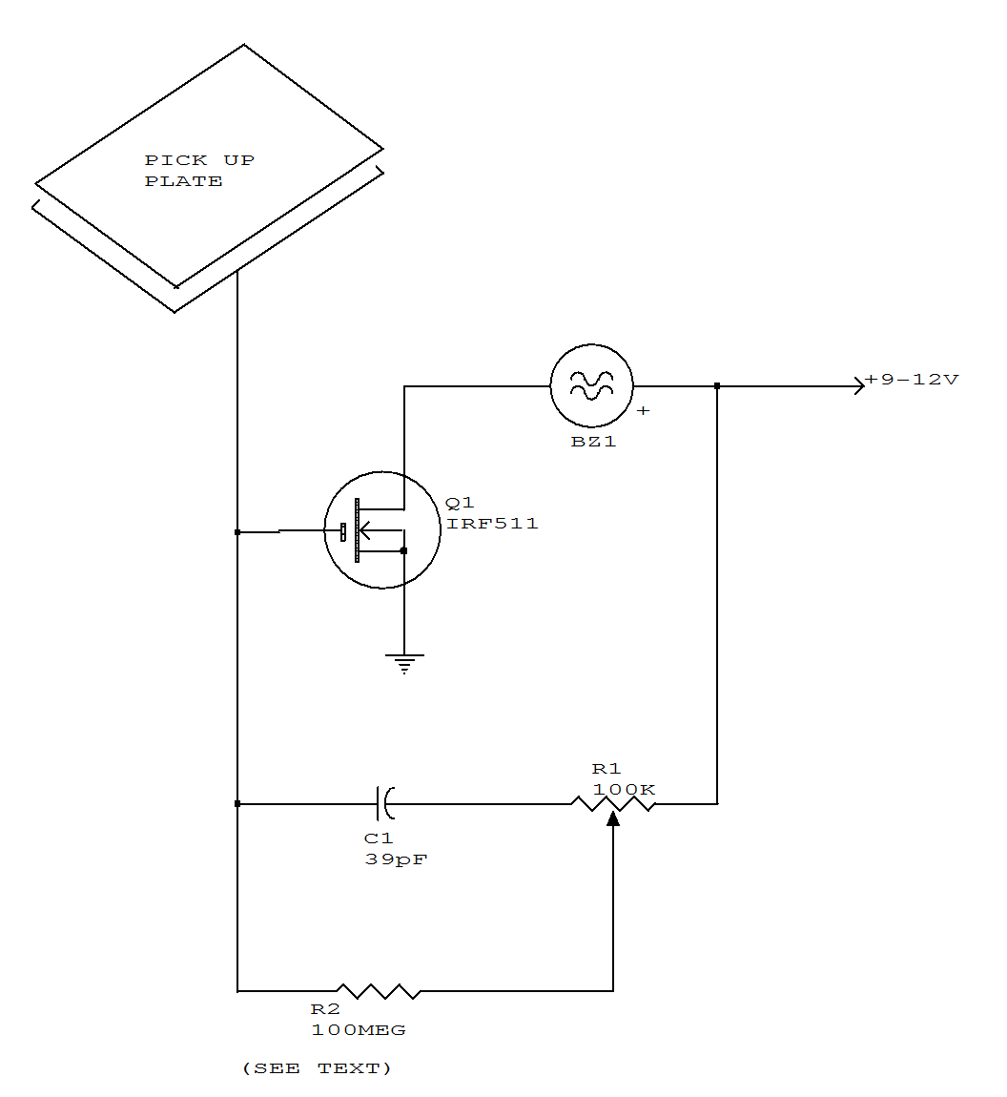

UNDERVOLTAGE/OVERVOLTAGE INDICATOR

This circuit will make the appropriate LED glow if the monitored voltage goes below or above the value determined by zener diodes D1 and D2.
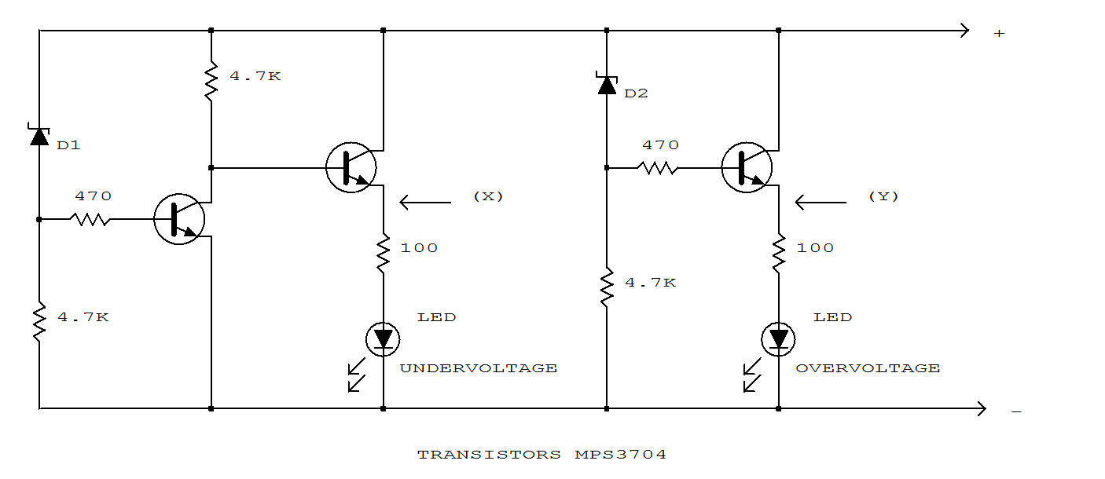
DIRECTION DETECTOR DECODER

This circuit, which was developed to monitor the traffic of bumblebees in and out of the hive, differentiates a -to-b motion from b-to-a motion. When used with an optical decoder, the circuit distinguishes clockwise from counterclockwise rotation and provides a resolution of one output pulse per quadrature cycle.
Q1 and Q2 are mounted so that a moving object first blocks one phototransistor, then both, then the other. Depending on the direction in which the object is moving, either IC1B or IC1D emits a negative pulse when the moving object blocks the second sensor. An object can get as far as condition 3 and retreat without producing an output pulse; that is, the circuit ignores any probing or jittery motion. If an object gets as far as condition 4, however, a retreat will produce an opposite-direction pulse.
The time constants R3C1 and R4C2 set the output pulse width. A 100 Kohm/100pF combination, for example, produces 10-us pulses. Select a value for pullup resistors R1 and R2 from the 10K to 100Kohm range, according to the sensitivity your application requires.

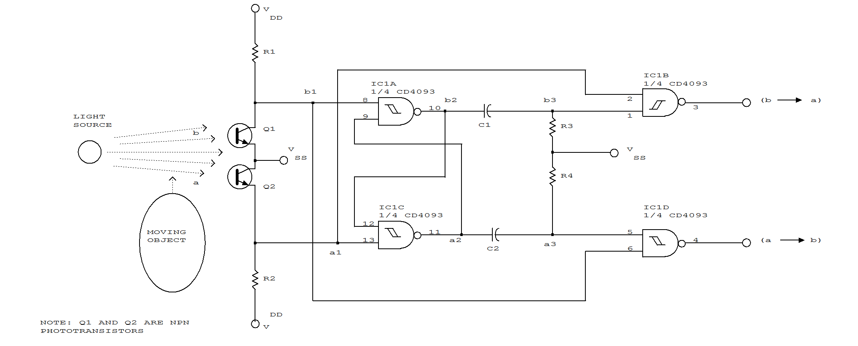
LOW VOLTAGE DETECTOR

The values of R1, R2, and D1 are selected for the voltage applied. Using a 12-volt battery, R1=10K, R2=5.6K and D1 is a 5-volt zener diode, or a string of forward-biased silicon rectifiers equaling about 5 volts. Transistor Q1 is
general-purpose UJT(Unijunction transistor), and Q2 is any small-signal or switching NPN transistor. When detector is connected across the battery terminals, it draws little current and does not interfere with other devices powered by the battery. If voltage drops below the trip voltage selected with the R1 setting, the speaker beeps a warning. The frequency of the beeps is determined by the amount of undervoltage. If other voltages are being monitored, select R1 so that it draws only 1 mA or 2mA. Zener diode D1 is about one-half of the desired trip voltage, and R2 is selected to bias it about 1 mA.
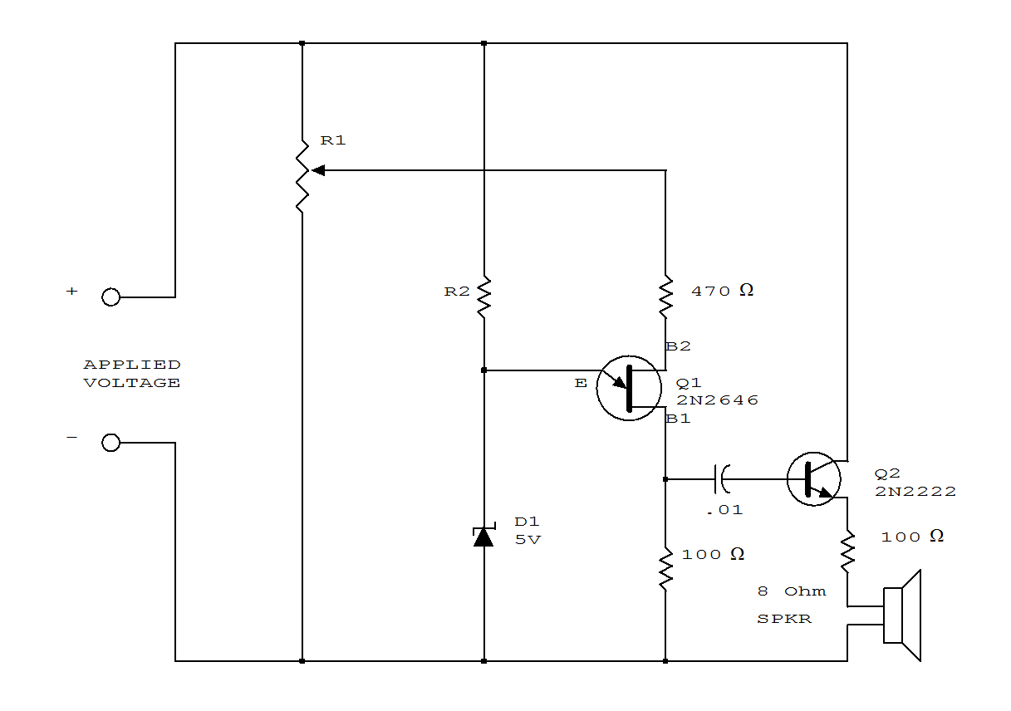
MISSING-PULSE DETECTOR

This circuit will detect a missing pulse or abnormally long spacing between consecutive pulses in a train of pulses. The timer is connected in the monostable mode. The time delay should be set slightly longer than the timing of the input pulses. The timing interval of the monostable circuit is continuously retriggered by the input pulse train, V1. The pulse spacing is less than the timing interval, which prevents Vc from rising high enough to end the timing cycle. A longer pulse spacing, a missing pulse, or a terminated pulse train will permit the timing interval to be completed. This will generate an output pulse, Vo as illustrated in Fig.25-3b. The output remains high on pin 3 until a missing pulse is detected at which time the output decreases.
The NE555 monostable circuit should be running slightly slower, lower in frequency, than the frequency to be analyzed. Also, the input cannot be more than twice this free-running frequency or it would retrigger before the timeout and the output would remain in the low state continuously. The circuit operates in the monostable mode at about 8 kHz, so pulse trains of 8 to 16 kHz can be observed.

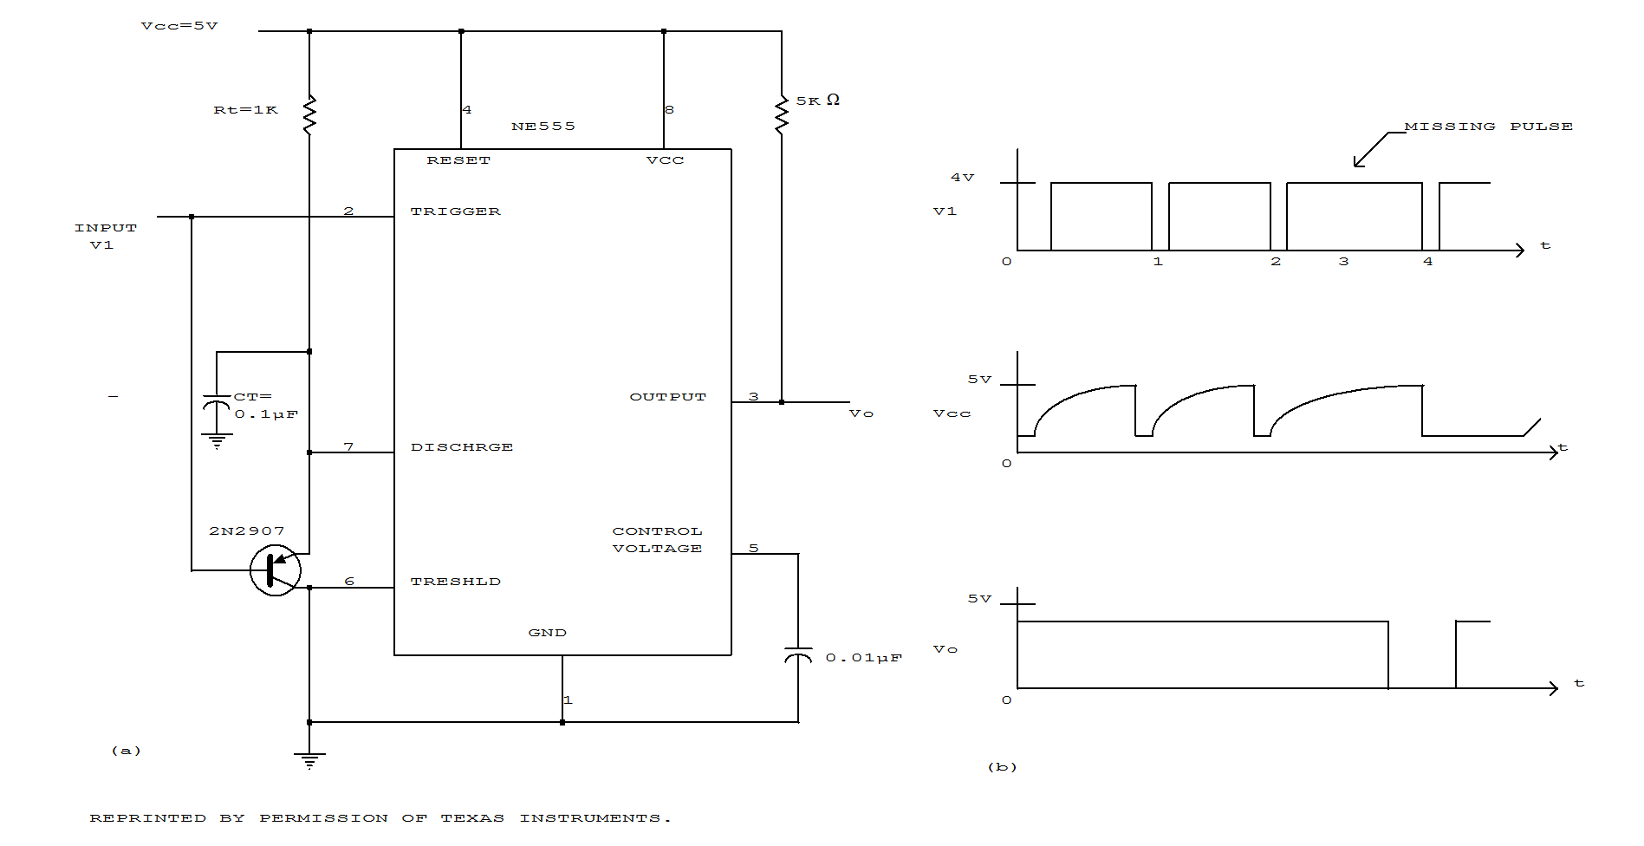
BAR DISPLAY WITH ALARM FLASHER
